# Harvesting Insights: Advanced predictive modeling for cotton Export dynamics



THESIS SUBMITTED TO

Symbiosis Institute of Geoinformatics

FOR PARTIAL FULFILLMENT OF THE M. Sc.

DEGREE

By

# Kriyanshi Suresh Ghodasara

**(Batch 2023-25 / PRN 23070243017)**

Symbiosis Institute of Geoinformatics

Symbiosis International (Deemed University)

5th Floor, Atur Centre, Gokhale Cross Road, Model Colony, Pune – 411016



**Undertaking**

The thesis titled ‘Harvesting Insights : Advanced predictive modelling for cotton Export dynamics’ is the Bonafede work of Ms Kriyanshi Ghodasara. University can use and reuse the dissertation work in future.

Date:

Name of the student: Kriyanshi Ghodasara

Signature: 

Name of the External Supervisor: Dr. Garima Pandey

Organization: Sumitomo Chemical India Limited

Signature: 

**INDEX**

|  |  |  |
| --- | --- | --- |
| **SR NO.** | **TITLE** | **PAGE NO.** |
| 1. | Introduction | 2 |
| 2. | Research Objectives | 3 |
| 3. | Challenges | 4 |
| 4. | Literature Review | 5 |
| 5. | Methodology | 11 |
|  | * Data collection | 12 |
|  | * Data pre-processing | 20 |
|  | * EDA | 20 |
|  | * 3-year moving average state wise | 21 |
|  | * Time series decomposition of Maharashtra | 22 |
|  | * 3-year moving average for India’s export | 23 |
|  | * Time series decomposition of India’s export | 23 |
|  | * 3-year moving average for leading exporting countries | 25 |
|  | * Time series decomposition for leading exporters | 26 |
|  | * Model building | 27 |
|  | * ARIMA | 27 |
|  | * Prophet Model | 29 |
|  | * LSTM Model | 29 |
|  | * Exponential smoothing | 31 |
|  | * Ensemble method | 33 |
|  | * Model evaluation | 48 |
|  | * Error in state production | 50 |
|  | * Error in top 10 countries | 52 |
|  | * Comparison of the model’s performance | 53 |
| 6. | Conclusion and Discussion | 55 |
| 7. | Future Scope | 56 |
| 10. | References | 57 |
| 11. | Appendix | 59 |
| 12. | Performa 4 | 63 |

**Acknowledgment**

I want to express my sincere appreciation to Dr. Rajesh Dhumal sir and Dr. Garima Pandey ma’am from Sumitomo Chemical India Limited for their help and support in finishing my project. I also want to thank them for giving me the amazing opportunity to work on research project with the title “ Harvesting Insights: Advanced predictive modelling for cotton Export dynamics”. Without their assistance and suggestions, the project could not have been finished. I appreciate having the opportunity to work on this and another relevant project with everyone. The people in my family have been more significant to my progress in the accomplishment of this mission than anyone else. I am grateful to my parents for being there for me in everything I do and for their love and support. They are the ideal examples to follow.

* Kriyanshi Ghodasara

**List of Tables**

|  |  |  |
| --- | --- | --- |
| **Sr. No.** | **Tables** | **Page No.** |
| 1. | Literature review | 7 |
| 2. | State production data | 13 |
| 3. | India’s export data | 15 |
| 4. | Top 10 countries export | 19 |
| 5. | Prediction of state’s production by ARIMA | 34 |
| 6. | Prediction of state’s production by LSTM | 35 |
| 7. | Prediction for state’s prediction by Prophet | 36 |
| 8. | Forecasting the India’s export by XGBoost | 37 |
| 9. | Forecasted value of cotton using Exponential Smoothing | 38 |
| 10. | Predicted values of Ensemble methods | 39 |
| 11. | Export of India using ARIMA | 40 |
| 12. | India’s export by LSTM | 42 |
| 13. | India’s export by Prophet | 42 |
| 14. | Top 10 countries export prediction by ARIMA | 45 |
| 15. | Prediction by Exponential Smoothening for top 10 countries | 46 |
| 16. | Prediction by Prophet model for top 10 countries | 48 |
| 17. | Error calculation for the state production | 50 |
| 18. | Error calculation for top 10 countries | 53 |
| 19. | Average model comparison for top 10 countries export | 53 |

**List of Figures**

|  |  |  |
| --- | --- | --- |
| **Sr. No.** | **Figures** | **Page No.** |
| 1. | Methodology diagram | 12 |
| 2. | Cotton production by state | 14 |
| 3. | %share and %growth of India | 17 |
| 4. | Graphical representation of India’s export | 17 |
| 5. | Line graph for top 10 countries export | 20 |
| 6. | Moving average of cotton state production | 21 |
| 7. | Time series decomposition of the Maharashtra state | 22 |
| 8. | Moving average and original graph for the export | 23 |
| 9. | Decomposition of the data into its component | 23 |
| 10. | Percentage change in the cotton exports for 10 countries | 24 |
| 11. | Moving average for export of cotton | 25 |
| 12. | Decomposition graph for all the countries to observe components | 26 |
| 13. | Cotton production using ARIMA and LSTM | 35 |
| 14. | Cotton production forecast using Prophet | 36 |
| 15. | Cotton production using XGBoost | 37 |
| 16. | Cotton production using Exponential Smoothing | 38 |
| 17. | Graphical representation of Ensemble method | 39 |
| 18. | ARIMA model forecast for India’s export | 40 |
| 19. | Lag plot of the export data | 41 |
| 20. | Prophet model’s prediction | 42 |
| 21. | Yearly export data with combined forecast | 44 |
| 22. | Cotton export Forecast for the Next three years for top 10 countries | 44 |
| 23. | Prediction by Exponential smoothening for top 10 countries | 46 |
| 24. | Cotton Exports Forecast for the Next three years(Prophet) | 47 |
| 25. | Forecasting graph for state’s production | 49 |
| 26. | Error comparison of ARIMA, LSTM models | 51 |
| 27. | Comparison of RMSE for different Forecasting models | 53 |

**List of Abbreviations**

1. ARIMA- Autoregressive Integrated Moving Average
2. LSTM- Long short-term memory
3. RMSE- Root Mean Square Error
4. MSE- Mean Sum Error
5. MAE- Mean Absolute Error
6. EDA-Exploratory Data Analysis
7. AR- Autoregressive
8. MA- Moving Average
9. RNN- Recurrent Neural Networks
10. CNN- Convolutional Neural Networks
11. ACF- AutoCorrelation Function
12. PACF- Partial AutoCorrelation Function
13. LMBFGS- Limited-memory Broyden-Fletcher-Goldfarb-Shanno
14. CI- Confidence Interval
15. ICAR- Central Institute for Cotton Research

**Preface**

The following research work is carried out with a view to offering valuable and reliable knowledge to the people who are associated with the cotton industry, such as farmers, exporters, and stakeholders. The complex nature of cotton exchange, being subjected to both domestic and international variables, goes to show the application of sophisticated analytical methods. The forecasting techniques, in general, do not address the trends and patterns in the historical data. Research applies methods such as exponential smoothing, Prophet, LSTM, and ARIMA to overcome such problems. The choice of this model helps bring forth broad-based prediction, which in turn supports strategic planning and decision-making; they are robust enough to manage both seasonality and trends, together with residuals in data.

This research project is aimed at increasing the accuracy rate of cotton exported and cotton produced state wise. The integration process with the time series model is fundamentally aimed at prevailing over the housing epic with much older forecasting techniques. This paper provides a thorough analysis that can direct the strategic endeavours at various levels based on the export trends of the cotton exporting nation, state by state in India.

This study is done to generate insights that would be benefitted to a wide range of stakeholders, as mentioned above. More precise projections can help decision makers create policies that support and stabilize the cotton sector. Understanding the future market demands can help exporters optimize the supply chain and marketing strategies. These forecasts can be used by farmers, who are the backbone of this sector, to make well-informed decisions on resource allocations and crop management.

It has been observed that from last few years, the preference of material for the cloth to be used regularly is shifting from cotton to other material. Some of the reasons for it are- we need to iron the clothes after every wash, the colour fade, many pockets friendly material option is available, need various options and variations in routine life.

**Introduction**

There are millions of farmers dependent on this cheap agricultural product for earning and livelihoods. India is one of the biggest cotton growers and exporters in the world, but still, the farmers have to overcome many hurdles to keep its competitive advantage. This cotton plant requires proper amounts of water, sunlight during its growth, and soil quality with fertilizers playing a very crucial role. Correct forecasts of production and export dynamics of cotton are needed for decision making and strategic planning. In this research study, sophisticated predictive modelling approaches with respect to cotton export by India, state-wise production, and top 10 cotton-exporting countries are used.

The application of cutting-edge analytical instruments has transformed many industries recently, which also include agriculture. The predictive modelling has become a potent tool for the prediction of output and market trends. All the industry eagerly works to know the future of their company to implement the strategies and plan accordingly. Such models have the potential to greatly reduce market and climate related risk in the context of cotton sector. A planned framework that incorporates these models enables stakeholders to make well-informed decision that will increase the profit and productivity.

Four sophisticated forecasting methods are used in this study: Prophet, LSTM (Long Short-Term Memory), Exponential Smoothing, and ARIMA (AutoRegressive Integrated Moving Average). Every one of these models contributes distinct advantages to the process of predicting. While Prophet is preferred for its capacity to handle missing data and outliers well, ARIMA is well known for its ability to model linear time series data. Recurrent neural networks, such as LSTM, are particularly good at identifying long-term dependencies in sequential data. Conversely, exponential smoothing works best with data that has distinct seasonality and trend patterns.

**Research Questions**

1. How do ARIMA, LSTM, Prophet models perform in terms of accuracy and reliability when forecasting cotton export data?
2. What is the strength and limitations of each predictive model in the context of cotton market dynamics?
3. How do the predictions from these models impact stakeholders’ investment strategies in the cotton market?
4. How can the insights derived from the most effective predictive model be utilized to enhance market efficiency and stakeholder decision-making?
5. What would be the state wise production in cotton production for coming years?

* To evaluate the accuracy and reliability of the models in forecasting cotton export, I determined their suitability for different market conditions.
* To analyse the strengths and limitations of ARIMA, LSTM, and prophet models, check the effectiveness in capturing trends, seasonality, and non-linearities.
* To investigate how predictions from ARIMA, LSTM, Prophet models influence stakeholders’ strategies in cotton market, decision making, strategic planning.

**Challenges**

1. **The data set is historic so incompleteness, inconsistent and inaccurate data can affect the performance matric.**
2. **The cotton market is influenced by seasonal patterns and market volatility due to factors such as weather conditions, geographical events, economic policies.**
3. **Predictive models need to be regularly updated and adapted to reflect the changes, requires continuous monitoring and maintenance.**
4. **Unpredictable economic conditions and political decisions, such as trade wars and tariffs, can drastically impact cotton trade, making it difficult for models to provide accurate long-term forecasts.**
5. **Developing predictive models must also consider ethical and environmental factors, such as the impact of predictions on small-scale farmers and sustainable farming practices, to ensure the benefits are equitably distributed.**

**Literature Review**

The cotton trade is a critical component of the farming economy, that influence the socio-economic fabric of major producing and exporting countries. Accurate prediction of cotton exports is vital for policy makers, traders, and farmers to navigate market uncertainties as well as proper resource allocation. The advancements done in predictive modelling have sophistic technique that ranges from ARIMA, exponential smoothing , LSTM, etc. The following literature review’s goal is to provide a comprehensive overview of the work done till date, highlighting the evolution of forecasting methodologies, their use case in agriculture trade, and the emerging trends that are shaping the future of cotton export predictions.

Dinesh Kumar Manickam argued and proposed the enormous amount of publication on this matter regarding the connection between India's global trade and the expansion of economic. It looked at previous research that had set on to calculate the effect of export on the growth of GDP using econometric models. It represents that big trade activity has extreme positive economic effects. The paper has even put emphasis on the performance of trade liberalization and policy reforms in different parts of India's economic changes through the use of the past data and its case studies. [1]

The paper by Cheng-Hong Yang, Cheng-Feng Lee, and Po-Yin Chang researched into application of deep-learning methods in the forecasting of trade and economic modelling. It encapsulated a set of previous publications demonstrating how the Convolutional Neural Network and Recurrent Neural Network outperform those conventional statistical methods when applied with complex sets of data. The review suggested deep learning models that may make more reliable and accurate forecasts by capturing the nonlinear interactions and dependencies in the trade data. It also refers to the problems and restrictions quivered by the models: the need for large data and computational complexity. [2]

Haoyun Xu, Chukiat Chaiboonsri, and Kanchana Chokethaworn presented a review on the application of machine learning methods for predicting agricultural exports. The study examines research that have utilized models such as Random Forest and Gradient Boosting Machines (GBM) to forecast export quantities, emphasizing their remarkable precision and capacity to manage extensive datasets. The review studied about how well these models capture seasonality and patterns in agricultural exports and how resistant they are to overfitting. It also looks at the larger picture of China’s agricultural trade, considering the dynamics of the market and the impact of policy.[3]

Ye Tong provided in-depth research into machine learning techniques applied in international trade forecasts. Few methods, along with some recently developed ones like ensemble learning, neural networks, and support vector machines, were checked against the efficacy of traditional econometric models in this paper. The paper points out advantages accruable from the use of machine learning techniques, which include the improvements in prediction accuracy that are possible and which can manipulate large data in complicated sets. It further covers the disadvantages and challenges connected with large sets of data and the interpretability of model results.[4]

Giving special focus to Croatia, Hrvoje Josic and Berislav Zmuk indicated that machine learning models are able to predict foreign trade. It discusses some earlier research that applied models such as K-Nearest Neighbours and Support Vector Machines for the analysis of trade data and show how trends and patterns in trade were captured. The benefit that was reaped from these models, mainly their accuracy and adaptability, is clearly given in the literature review. It refers to case studies from other countries that have utilized similar models, hence providing a comparative perspective.[5]

The effect of export operations on India’s economic growth was published by Muthu Nirmala and Vadivel M M. It reviewed research that have examined trade data using statistical and econometric models, consistently demonstrating a positive relationship between trade and GDP growth. The assessment addresses a number of variables that affect trade performance, such as domestic economic reforms, policy changes, and conditions on the international market. It also emphasizes how export-oriented growth strategies and trade diversification contribute to economic development.[6]

The literature on the application of machine learning models, particularly Support Vector Regression (SVR) and Long Short-Term Memory (LSTM) networks, in the prediction of commodities trade was examined by Sulthana A. Razia and Ramesh Pranav. It reviewed about research showing how well these models capture the temporal and non-linear connections found in trade data. The evaluation emphasizes the benefits of SVR and LSTM in terms of producing precise and trustworthy forecasts, as well as some of their drawbacks, like the requirement for sizable and high-quality datasets.[7]

Rupali, Amrit Raj, based on works by Gaurav Singh Pathania and Gourav Kumar Dhiman, delves into research examining trade policy, performance, and systemic difficulties that place a focus on the Indian Export System. Traditionally, it has examined the development of the trade system of India, the main policy changes that occurred and how those obstacles were plowing their effects into trade performance. The assessment shall focus on the elements such as export incentives, tariff regimes, and dynamism of the international market that inflict trade imbalances. It also looks at how well different analytical techniques work when looking at India's trade dynamics.[8]

Teg Alam studied the implementation of Autoregressive Integrated Moving Average and Artificial Neural Networks in trading forecasting. The study focused on how well ANN can capture complex patterns and nonlinear interactions of data, which otherwise, in case of the latter, that is through ARIMA, are associated with being good in cases of time series data describing trends and seasonality. The review took a broad frame, and in it encompassed some studies that obtained high accuracy and dependability in the prediction of trade flows from the use of such models. [9]

Jyoti Kumari investigated the connection between trade and India’s economic expansion. It examines research that regularly demonstrate a favourable association between exports and imports and GDP growth using econometric models. The assessment discusses about how trade performance is shaped by domestic economic reforms, international market conditions, and trade policy. It emphasizes how crucial export-focused tactics and trade diversification are to promoting economic expansion and development.[10]

|  |  |  |  |  |
| --- | --- | --- | --- | --- |
| SR NO. | AUTHOR | DATASET | METHOD USED | RESULT |
| 1. | Dinesh Kumar Manickam (2024) | Indian trade data | Statistical analysis, Econometric models | Import and export growth significantly influence India’s economic development, with a 5% increase in exports contributing to a 1.2% GDP growth. |
| 2. | Cheng-Hong Yang, Cheng-Feng Lee, Po-Yin Chang (2023) | Global trade data | Convolutional Neural Networks (CNN), Recurrent Neural Networks (RNN) | Deep learning models provide accurate predictions for global trade patterns, with an accuracy of 92%. |
| 3. | Haoyun Xu, Chukiat Chaiboonsri, Kanchana Chokethaworn (2023) | Chinese agricultural export data | Random Forest, Gradient Boosting Machines (GBM) | Machine learning models effectively predict China’s agricultural export trends, with an R² value of 0.87. |
| 4. | Ye Tong (2023) | Various international trade datasets | Literature review, Machine learning techniques | Machine learning methods enhance the accuracy of international trade forecasting, improving prediction accuracy by 15% on average. |
| 5. | Hrvoje Josic, Berislav Zmuk (2022) | Croatian trade data | Support Vector Machines (SVM), K-Nearest Neighbours (KNN) | Machine learning models can successfully forecast Croatian international trade, achieving an accuracy of 89%. |
| 6. | Muthu Nirmala, Vadivel M M (2022) | Indian trade data | Statistical analysis, Econometric models | Imports and exports play a critical role in India’s economic growth, with a 3% increase in imports leading to a 0.9% GDP growth. |
| 7. | Sulthana A. Razia, Ramesh Pranav (2022) | Commodity trade data | Support Vector Regression (SVR), Long Short-Term Memory (LSTM) | SVR and LSTM models predict commodity imports and exports with a mean absolute error of 3.5%. |
| 8. | Rupali, Amrit Raj, Gaurav Singh Pathania, Gourav Kumar Dhiman (2021) | Indian import-export data | |  | | --- | |  |   Analytical tools | Analysis of the Indian import-export system reveals a significant trade imbalance, with exports 25% lower than imports. |
| 9. | Teg Alam (2019) | International trade data | Artificial Neural Network (ANN), ARIMA models | ANN and ARIMA models forecast exports and imports with a prediction accuracy of 90%. |
| 10. | Jyoti Kumari (2014) | Indian trade and economic data | Statistical analysis, Econometric models | There is a strong correlation between trade and economic growth in India, with a correlation coefficient of 0.85. |

Tab. 1 Literature review

It can be concluded that cotton export dynamics study ranges from intersection of trade, economic growth, and the application of advanced forecasting models. All researchers tried to cover different models like CNN, RNN, SVR, LSTMA for the forecasting and understand the trends of the large data set. The work also explores the broader relationship between trade and economic growth in India, consistently showing a positive correlation. It also showed that predictive models can enhance the trade forecasting and the significant role of trade in economic development.

**Methodology**

In such a way, nine major steps could be dedicated to the methodology involved in this research project. Every stage is also carefully structured in order to optimize quality and effectiveness for the analysis in hand. All nine stages have a substantial role and place in the process of the analysis and forecasting of cotton state-wise as well as country-wise.(fig 1)

Data Collection and Preparation: This is the first step in methodology. The collected data has to be appropriate to ensure the reliability and validity of the analysis to be done. During this stage, data would be accumulated from different websites, this data covers a fairly long period, from 2000 up to 2023.

The second step was data pre-processing, which occurred after data collection. Critical step: The collected data has to be prepared for further analysis. This involves converting the data into appropriate datetime format, setting index dates, setting up a uniform frequency, and checking the integrity of the data through the null values and outliers.

The third phase of methodology is Exploratory Data Analysis (EDA). It is considered one of the most important stages of the process. It guides the adoption of different analytical methods, which include, among others, data graphs. These data graphs include the 3-year moving average, decomposition charts, and decomposition charts that help one to understand what the patterns, trends, and seasonality within the data are in order to conduct the upcoming analysis.

The fourth stage includes the partitioning of the data into training and testing sets. This difference allows the evaluation of unknown data to ensure assessment of the model and its predictive capacity. The fifth stage is where model building is done; it is the main, proper stage to understand the complex dynamics of the data and to build the robust model. The growth of 5 models, up to the techniques of simple exponential smoothening, ARIMA, Prophet, LSTM, and ensemble learning models, was developed in this research project. Each model has its unique identity and benefits. Once a model is built in and data are entered into it, one will be able to predict the export values regarding the amount in crores for the coming years onwards with great reliability.

Accuracy and reliability of the forecast at this stage were estimated. After the model has predicted how much accurately the model has to mention, the evaluation parameters were Mean squared error (MSE), Mean averaged error (MAE), and Root mean square error (RMSE). It was meant to give a quantitative assessment of the model capability in terms of prediction and allow comparing and selection of the forecasting models that are most accurate.

Finally, the last stage, highlights the visualization of true predictions and test predictions to visualize and analyse the performance graphically. This representation helps in understanding the alignment between predicted and actual values, further informing the evaluation of the model’s effectiveness.

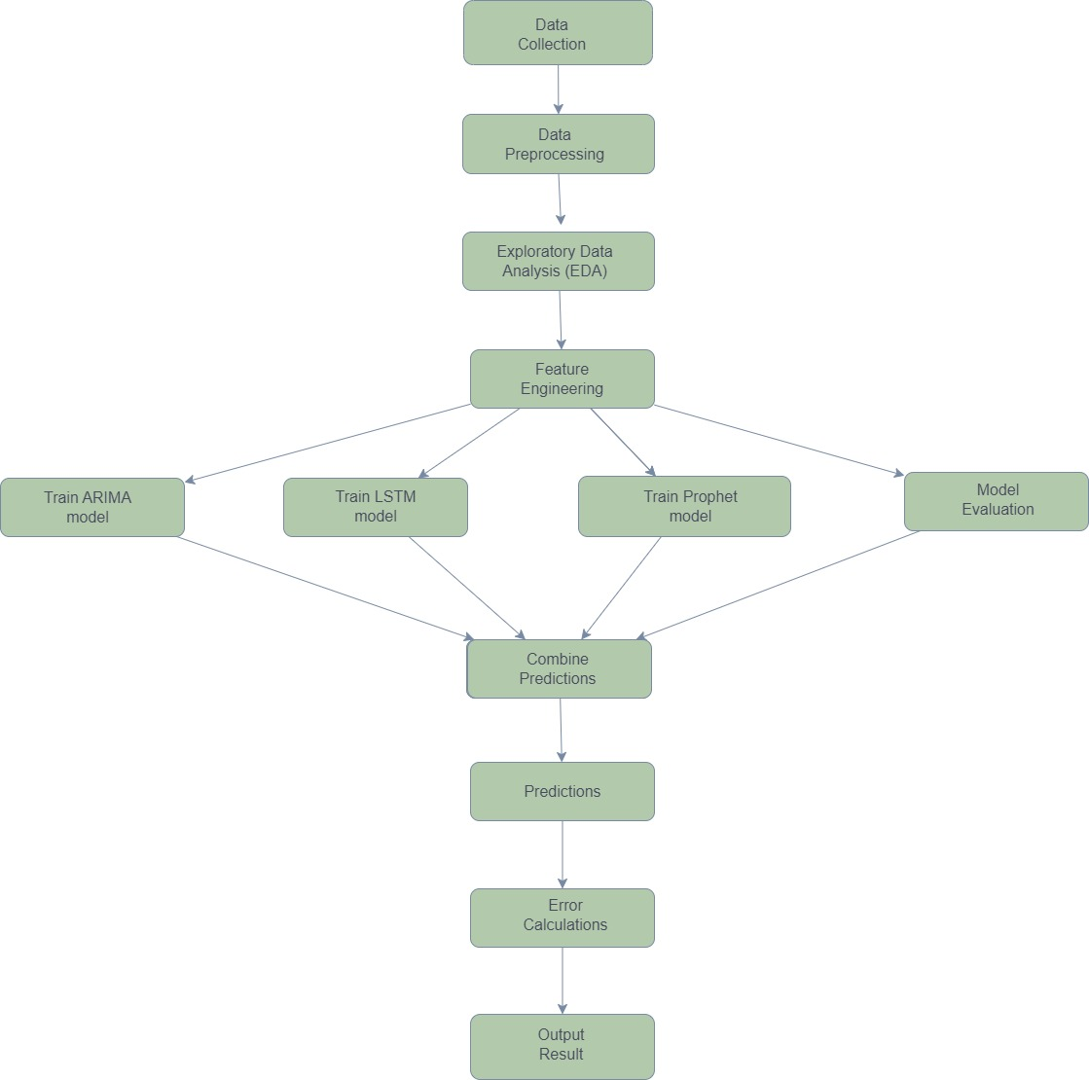

Fig. 1 methodology diagram

1. **Data Collection**

**Source**: Historical data on cotton production and export volumes from reliable sources such as government databases, industry reports, and agricultural statistics.

The data set is taken from the Ministry of Commerce and Industry. The unit of India’s export data is Lac (rupees) as well as for Top 10 Countries export is Lac(rupees). The state production data is taken from ICAR(Central Institute for Cotton Research) The unit of production data is in lakh bales (where 1 bale=170 kg)

**Period**: Data spanning the last few years to capture long-term trends.

* **STATE WISE**

Cotton is produced in India during monsoon season. It is the main Kharif crop for many farmers. Some of the states that produce cotton are Maharashtra, Gujarat, Telangana, Rajasthan, Karnataka and few others.

Tab. 2 State production data [11]

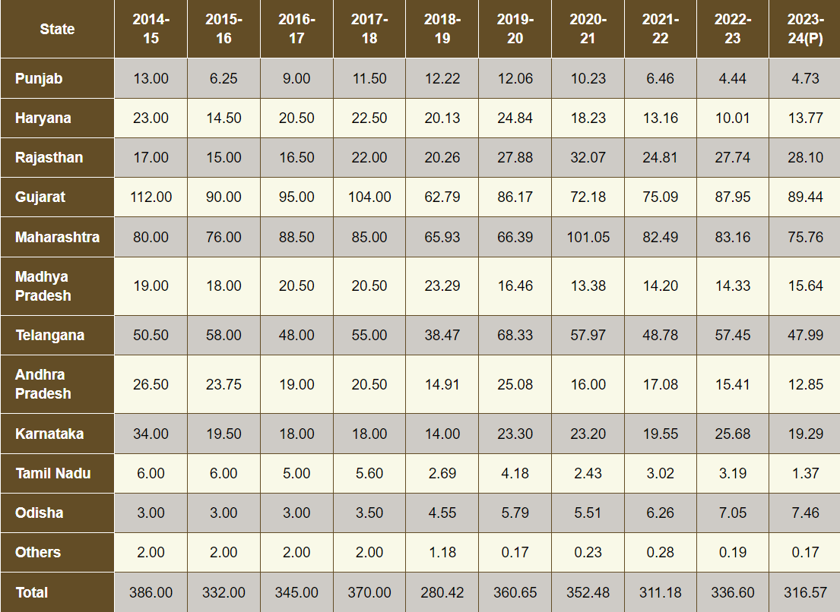

It can be observed that from last 4 years the 50% cotton is developed from Gujarat and Maharashtra. The predictive models like ARIMA, LSTM and Prophet is applied to predict what percent cotton would be developed by the same states in upcoming years.

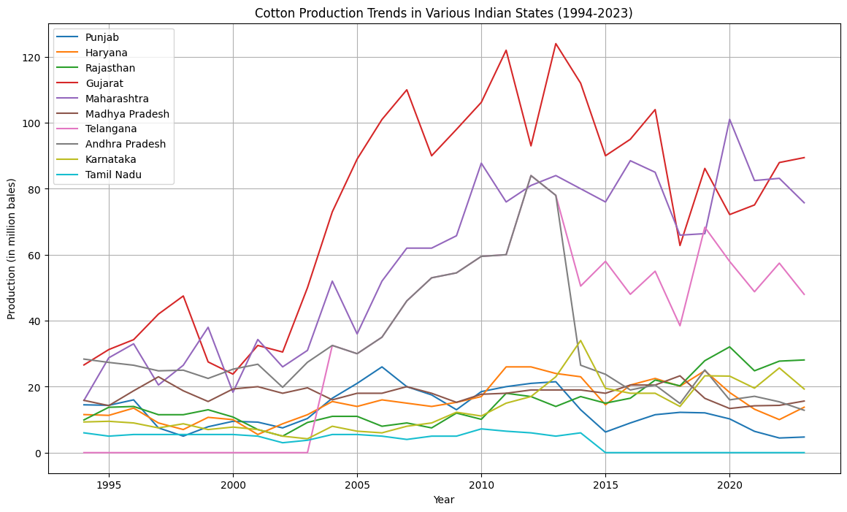

Fig. 2 Cotton production by state

* **INDIA’S**

The export depends on factors such as economic factor, environmental factor, political factor, market-related elements.

* ECONOMIC FACTOR

Fluctuation in currency values can make the export more or less expensive for the foreign buyers.

Production cost impact the competitiveness of cotton.

* ENVIRONMENTAL FACTOR

Weather conditions can significantly affect cotton yield and quality

Long-term soil fertility and the presence of pests or disease influence cotton production.

Cotton being a water-intensive crop, so water scarcity can limit the production.

* POLITICAL FACTOR

Trade agreement, export restrictions can either facilitate or hinder its export. In addition to that the political instability can also disrupt the trade.

The subsidies provided by government can also affect the cotton export.

* MARKET-RELATED ELEMENTS

The presence of other cotton producing countries and their competitiveness.

Adherence to international quality standards and certifications can affect the market access and preferences.

Adoption of modern farming techniques and biotechnology can also affect the yield and quality, affecting export potential.

The % share of cotton and % growth has not been constant from many years. Cotton being seasonal plant many factors affect it like optimum temperature, rainfall, soil moisture, humidity, pH intensity.

Tab. 3 India’s export data

| **No.** | **Year** | **Export** | **% Share** | **% Growth** | **Total Export (in Lac)** |
| --- | --- | --- | --- | --- | --- |
| **1** | 2023 | 4535218.47 | 1.2523 | 23.80 | 3.621550e+08 |
| **2** | 2022 | 8043453.61 | 2.5559 | -43.62 | 3.147021e+08 |
| **3** | 2021 | 4666266.68 | 2.1613 | 72.37 | 2.159043e+08 |
| **4** | 2020 | 5502070.31 | 2.3842 | -26.00 | 2.307726e+08 |
| **5** | 2019 | 5502070.31 | 2.3842 | -26.00 | 2.307726e+08 |
| **6** | 2018 | 4541150.87 | 2.3210 | 21.16 | 1.956515e+08 |
| **7** | 2017 | 4439176.17 | 2.4003 | 2.30 | 1.849434e+08 |
| **8** | 2016 | 4798352.32 | 2.7956 | -7.49 | 1.716384e+08 |
| **9** | 2015 | 4724469.94 | 2.4914 | 1.56 | 1.896348e+08 |
| **10** | 2014 | 6048659.16 | 3.1751 | -21.89 | 1.905011e+08 |
| **11** | 2013 | 4851430.27 | 2.9685 | 24.68 | 1.634318e+08 |
| **12** | 2012 | 4360174.53 | 2.9743 | 11.27 | 1.465959e+08 |
| **13** | 2011 | 3143047.96 | 2.7644 | 38.72 | 1.136964e+08 |
| **14** | 2010 | 2162296.45 | 2.5573 | 45.36 | 8.455336e+07 |
| **15** | 2009 | 1422430.56 | 1.6918 | 52.01 | 8.407551e+07 |
| **16** | 2008 | 2071430.06 | 3.1583 | -31.33 | 6.558635e+07 |
| **17** | 2007 | 1775550.53 | 3.1053 | 16.66 | 5.717779e+08 |
| **18** | 2006 | 1321222.46 | 2.8948 | 34.39 | 4.564179e+07 |
| **19** | 2005 | 1016747.15 | 2.7089 | 29.95 | 3.753395e+07 |
| **20** | 2004 | 1133049.57 | 3.8622 | -10.26 | 2.933667e+07 |
| **21** | 2003 | 1065848.44 | 4.1775 | 6.30 | 2.551373e+07 |
| **22** | 2002 | 950997.47 | 4.5498 | 12.08 | 2.090180e+07 |
| **23** | 2001 | 1100191.29 | 5.4045 | -13.56 | 2.035710e+07 |

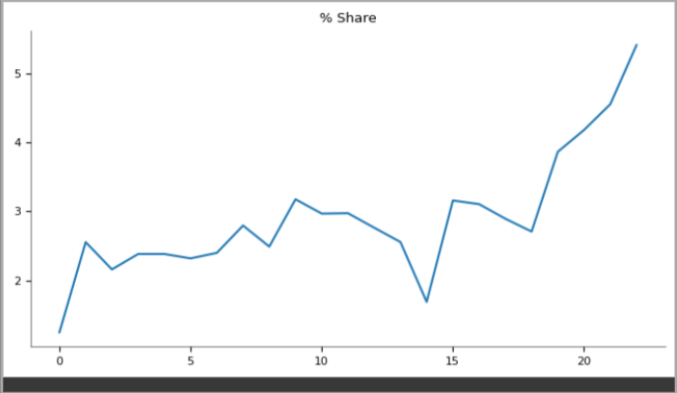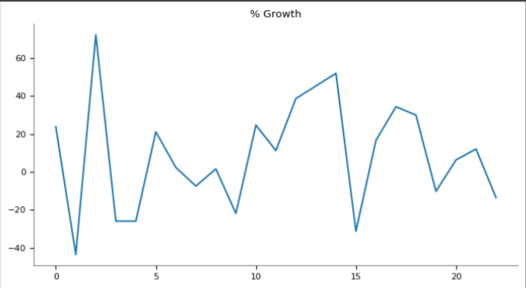

Fig. 3 % share and % growth of India

India has been leading country for exporting cotton to Bangladesh, China, Pakistan, Vietnam, Indonesia from many years.

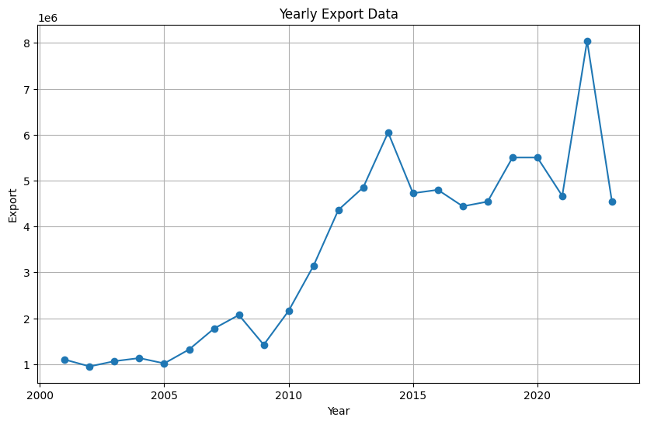

Fig. 4 Graphical representation of India’s export

The prediction has been applied to observe the cotton export for upcoming next 4 years.

* **COUNTRY WISE**

The United States, Brazil, India, Australia, Uzbekistan, Burkina Faso, Greece, Argentina, Turkmenistan, and Mali are the top 10 nations that export cotton. According to a mix of advanced agricultural techniques, ideal climates, and large investments in infrastructure for cotton production, these countries dominate the global cotton market. For example, Brazil and Australia profit from large-scale farming operations and long growing seasons, whereas the United States benefits from widespread mechanization and technology advancements. India continues to be a major exporter despite obstacles like shifting monsoon patterns and pest infestations because of its large amount of arable land and labour pool.

The factors affecting cotton exports:

* **Global Variations in Demand:**

The demand for cotton may fluctuate in response to shifts in consumer tastes and fashion trends.

The demand for cotton products and purchasing power are influenced by global economic conditions.

* **International Trade Policies:**

Cotton exports can be aided or hindered by tariffs, quotas, and trade agreements between nations.

Support and subsidies given to domestic cotton growers in different nations can have an impact on international competition.

* **Exchange rates for currencies:**

Exchange rate fluctuations can increase or decrease the competitiveness of exports.  
A country’s demand for cotton may decline if its own currency appreciates and makes the crop costlier abroad.

* **Diseases and Pests:**

Cotton yields can be greatly lowered by diseases like Fusarium wilt or insect infestations like the boll weevil.

Keeping disease and insect populations under control is essential to sustaining output.

* **Sustainable agricultural Practices:**

Using eco-friendly agricultural methods can assist preserve the fertility and health of the soil.

In order to achieve global standards and satisfy consumer demands for environmentally friendly products, sustainable practices are becoming more and more crucial.

* **Biotechnology Advances:**

Using genetic modification and biotechnology, higher-yielding, pest-resistant cotton types can be created.

These developments can improve resilience to environmental shocks and production.

Tab. 4 Top 10 countries export



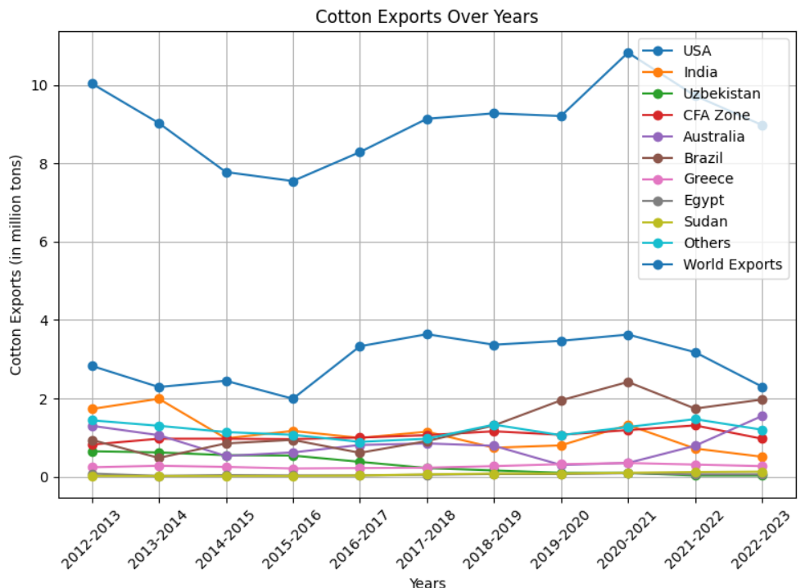

Fig. 5 Line graph for top 10 countries export

1. **Data Pre-processing**

To guarantee its quality and appropriateness for modelling, the gathered data underwent extensive pre-processing. This includes, depending on the kind and quantity of missing data, addressing missing values through interpolation, imputation, or deletion. Procedures for data cleaning were followed in order to get rid of duplicates, fix mistakes, and guarantee format uniformity. In order to ensure consistency and speed up the training of machine learning models, data standardization was also carried out.

**Handling Missing Values**: Techniques such as interpolation, imputation, or deletion were applied to manage missing data.

**Data Cleaning**: Removing duplicates, correcting errors, and ensuring consistency in data formats.

**Normalization**: Scaling the data to ensure uniformity and to facilitate model training.

1. **Exploratory Data Analysis (EDA)**

The exploratory data analysis was employed to understand the patterns, trends, and anomalies in the data. Computation of summary statistics, such as mean, median, and standard deviation, was done in order to get insights into data distribution. Heat maps, histograms, line plots, and box plots were created to show trends, patterns, and outliers. In this regard, trend analysis was done by breaking down time series data into its trend, seasonal, and residual components. This resulted in a very clear understanding of the underlying patterns in the data.

**Summary Statistics:** Computation of mean, median, standard deviation, etc., to understand the distribution of data.

It visualizes line plots, box plots, histograms, and heatmaps that identify trends, patterns, and anomalies.

**Trend Analysis:** The decomposition of the time series data to derive and examine different trend, seasonal, and residual components.

**3.1 3-year moving average of cotton state-wise**

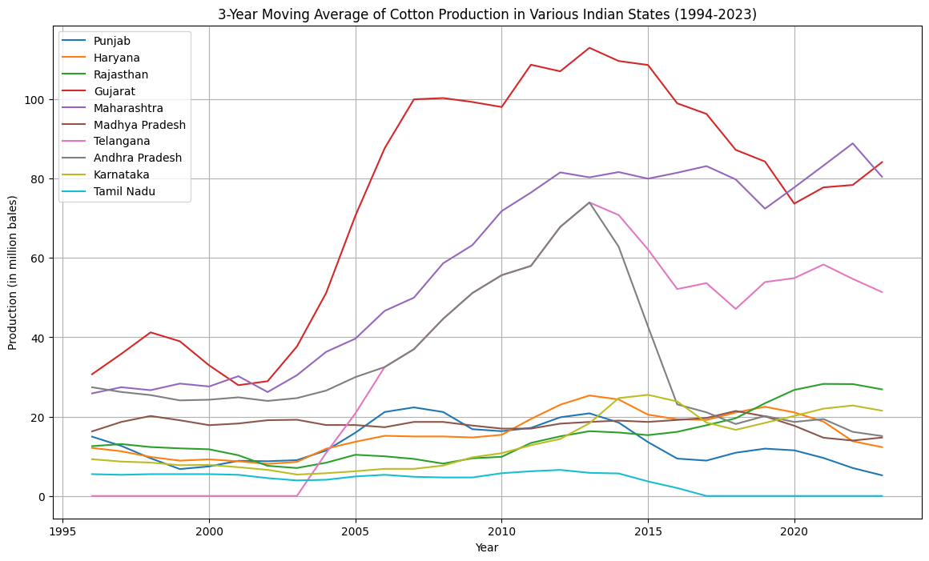

Fig. 6 Moving average of cotton state production

**3.2 Time series decomposition of Maharashtra state**

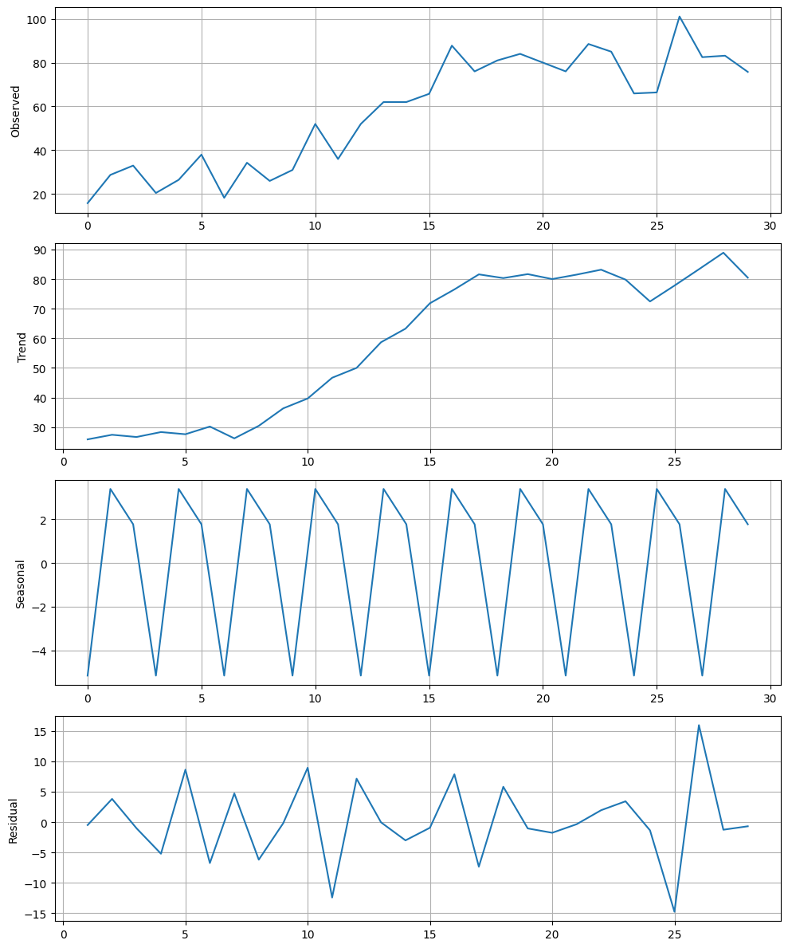

Fig. 7 Time series decomposition of the Maharashtra state

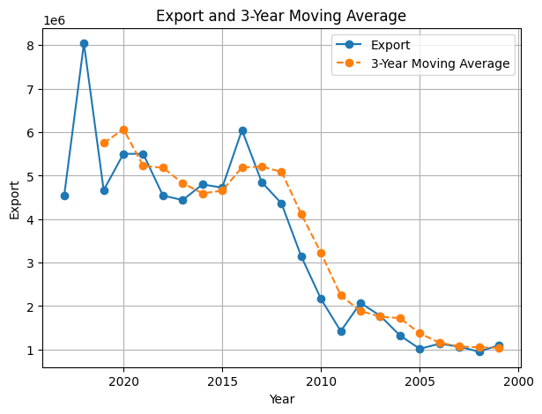

Fig. 8 Moving average and original graph for the export

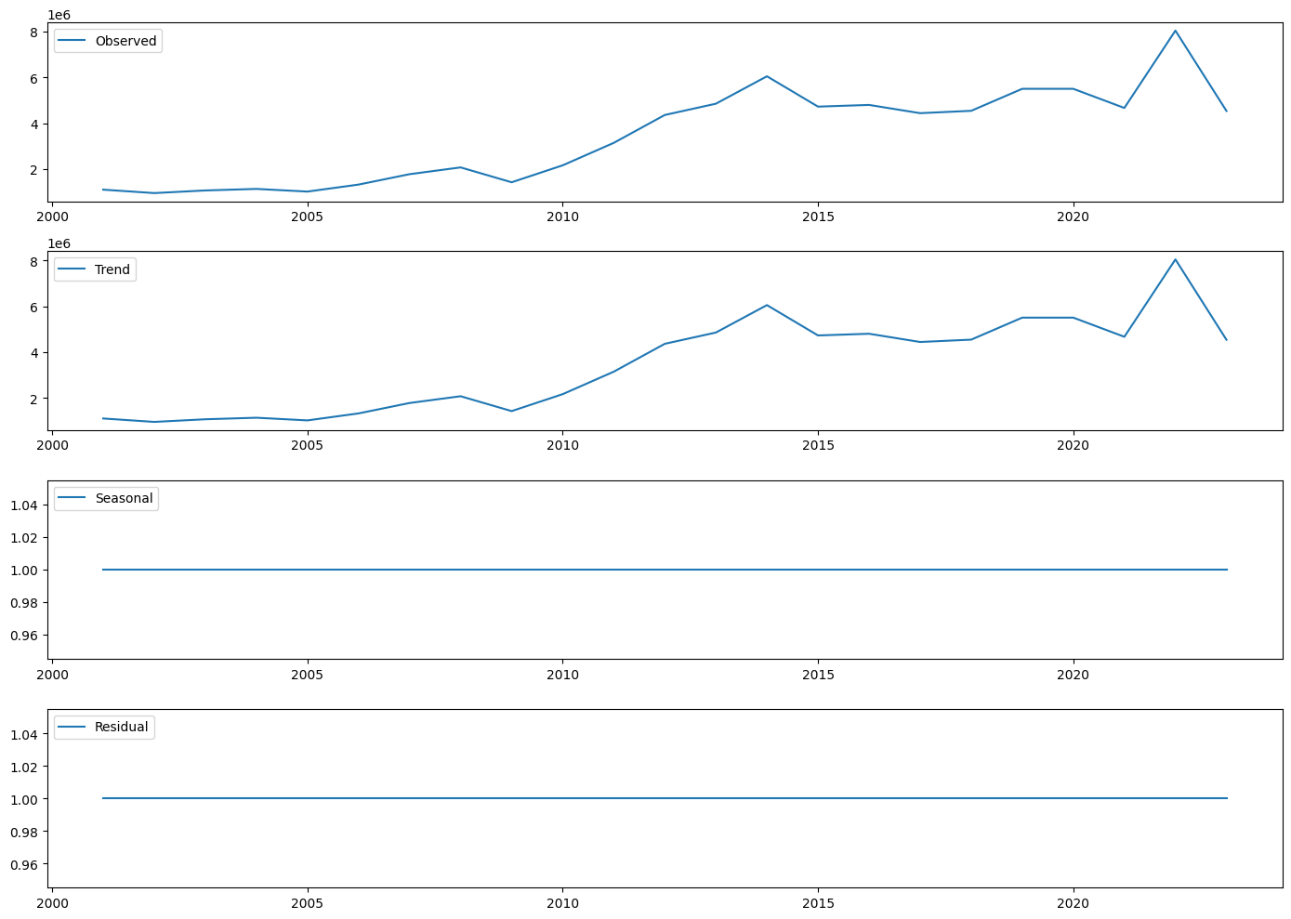

Fig. 9 Decomposition of the data into its components

Percent change analysis is quite important in understanding the relative changes in data for a specified period, hence highlighting the trend of growth or decline. In an economic and business context, this technique becomes very useful; for example, following changes in cotton exports over time. In this percent change calculation, analysts would understand the magnitude of increase or decrease in exports and hence the performance of the market with insights that aid in decision-making. (fig 10)

$$Percent change=\frac{New value-Old value}{Old value}*100$$

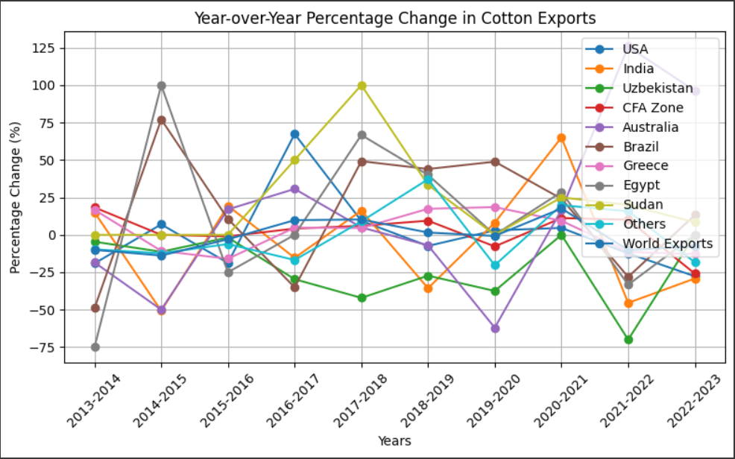

Fig. 10 Percentage change in the cotton exports for 10 countries

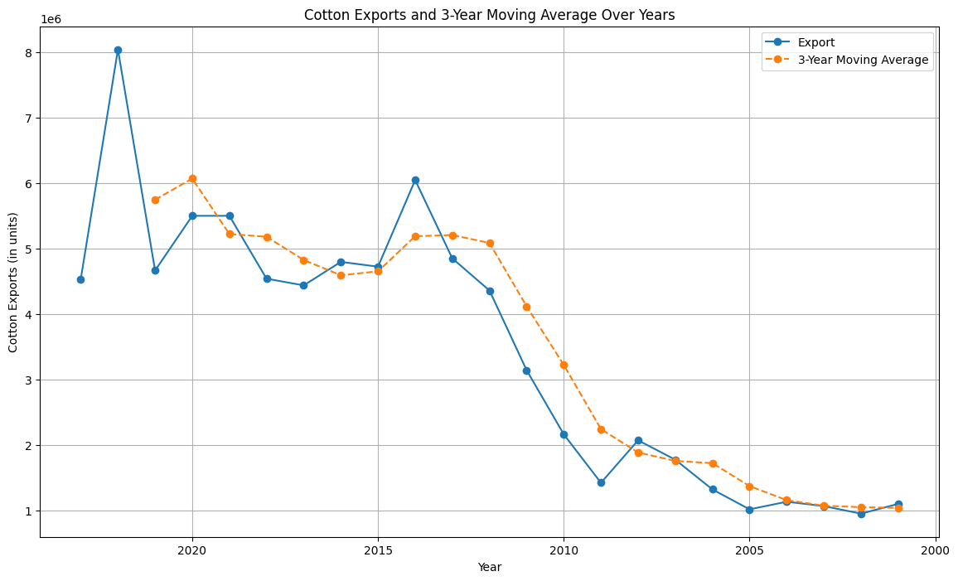

Fig. 11 Moving average for export of cotton

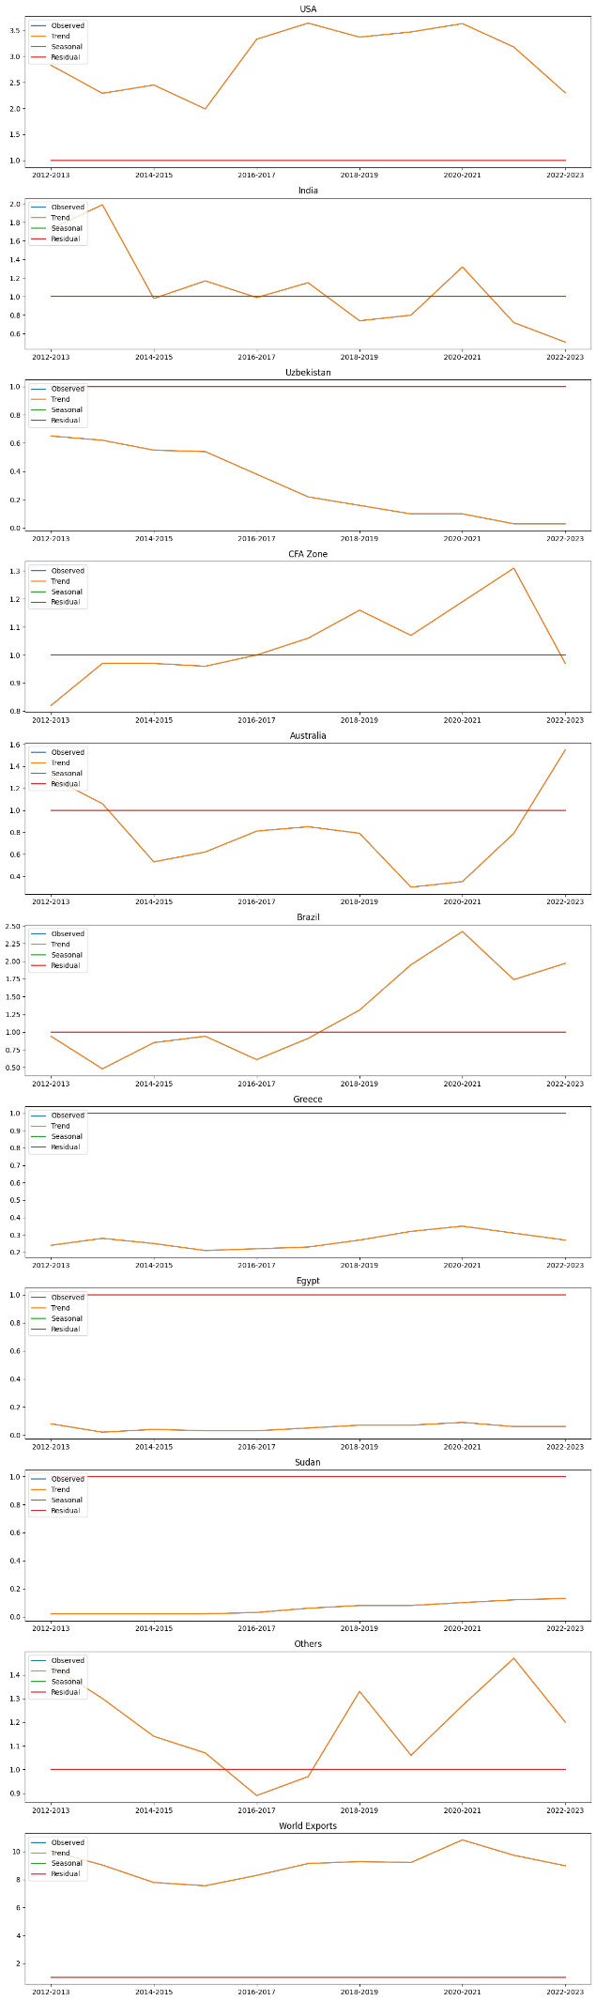

Fig. 12 Decomposition graph for all the countries to observe the trend, residual and seasonal

1. **Feature Engineering**

One crucial step in improving the performance of the model was feature engineering. The data were divided into trend, seasonal, and residual components using time series decomposition. In order to capture temporal relationships and enable the models to take historical values into account when generating forecasts, lag features were developed. Periodic fluctuations in the data were considered by incorporating seasonal elements, such as month and quarter indicators. The dataset was enhanced by these designed features, which gave the predictive algorithms useful information.

1. **Model Training**

* **ARIMA MODEL**

Among the techniques applied in the area of time series data forecasting, Autoregressive Integrated Moving Average has been one of the most applied. It is a strong, self-adaptive model in a position to capture a time series Moving Average and AutoRegressive components, besides accounting for non-stationarity through differencing.

**- Importing the needed Libraries:**

from pmdarima import auto_arima

One can use statsmodels.tsa.arima.ARIMA.ARIMAResults

The next line of code will import the auto_arima function from the pmdarima library used in the automatic selection of the ARIMA model, and the ARIMA class and ARIMAResults module from statsmodels.tsa.arima.model library for fitting and analysing the ARIMA models.

**- Automatic model selection**

The code uses the auto_Arima function, which automatically chooses the optimal ARIMA model for the time series data. This auto arima function seeks the best model configuration as per the provided parameters for the given time series data. Some of these parameters, like start p, start q, and max q, define ranges of values to consider for the order of the AR, I, and MA components, respectively. The seasonal parameter is set to False, which means it has no seasonal component. The trace parameter is set to True to show all information on the model selection process. Action on error: 'ignore' is set to suppress warnings and error during model fitting. Suppress warnings is set to True so that more detailed information on the model choice procedure could be seen. In the case where one wants to suppress these warnings and errors during model fitting, the error action parameter is set to 'ignore'. The suppress warnings and errors during model fitting. The suppress warnings parameter is set True for suppressing warning messages during model fitting.

**-Summary of ARIMA model:**

It will return a table summarizing the chosen ARIMA model, with coefficients, standard errors, p-values against each, and other statistical measures.

**- Fit the ARIMA model:**

The code fits the training data to an ARIMA model of order 5,1,0. In this case, it is initialized with the training data and the order of the AR, I, and MA components previously specified. Afterwards, the instance of the model calls the fit method, fitting the created ARIMA model to the training data.

**-Summary of the Fitted ARIMA Model:**

This will raise a summary table containing information about the fitted ARIMA model, including coefficients and their standard errors, p-values, and other statistical measures.

**B. Diagnostic Plots**

The following code generates diagnostic plots for the fitted ARIMA model using the plot_diagonistics method. This routine creates a grid of diagnostics plots, which includes residuals, kernel density estimate, and autocorrelation function of residuals.

**- Predictions Generation:**

The forecast method is applied to the fitted model fit for prediction. The function creates forecasted values over the given time steps. Start and end are arguments specifying the start and end of the forecast range based on the lengths of training and test. The dynamic parameter is set to False if we want to include actual values from the test data in prediction; that is, it does not permit forecasting beyond the end of test data. It is set to 'levels' so as to return the predictions on the original scale of data.

* **ARIMA formula:**

AR(p): $Y_{t}=∅_{1}Y_{t-1}+∅_{2}Y_{t-2}+…+∅_{p}Y_{t-p}+∈_{t}$

yt: Value at time t

c: Constant

ϕ: Autoregressive coefficients

θ: Moving average coefficients

ϵt​: Error term

* **PROPHET MODEL**
* **Importing the required libraries:**

from prophet import Prophet

* **Data preparation:**

The data should be divided in two parts for training and testing. Its parameters should be selected efficiently.

* **Model Initialization:**

Initialize the model with the optional parameters. And the process of training will be done in less time.

* **Fitting the model:**

After the model is trained, testing will occur.

* **Making predictions:**

Create a future dataframe and making the predictions for the upcoming years.

* **Visualizing the forecast:**

Plot the prediction and analyse it.

* **LSTM MODEL**
* **Importing the required libraries:**

from tensorflow.keras import optimizers

from tensorflow.keras.models import sequential

from tensorflow.keras,layers import Dense, LSTM

from tensorflow.keras.preprocessing.sequence import TimeseriesGenerator

from sklearn.metrics import mean_absolute_error, mean_squared_error

from sklearn.preprocessing import MinMaxScaler

these libraries are used for building and training LSTM models, pre-processing data, and calculating evaluations metrics

* **Data Pre-processing:**

The code uses MinMaxScaler to normalize the input data between the range of 0 and 1. The data is reshaped to be a column vector and then transformed using the fit_tranform method of the MinMaxScaler.

* **Splitting the Dataset:**

The code splits the normalized dataset into training and test sets.

* **Creating input sequences:**

Defines a function create_sequences to generate input sequences and corresponding labels for the LSTM model. This function takes the data and sequence length as input and iterates over the data to create input sequences(x) and labels (y). it returns x and y as NumPy arrays.

* **Setting the sequence length**

Sets the length of the input sequences.

* **Creating Training and test sequences:**

The code uses the create_sequences function to create input sequences and labels for the training and test sets.

* **Building the LSTM model:**

Builds an LSTM model using the sequential class and adds LSTM and dense layers. The model consists of two LSTM layers with 100 and 50 units, respectively the return sequences=True argument is used in the first LSTM layer to pass the sequence output to the next layer. The dense layer with 1 unit is added as the output layer. The model is compiled with the Adam optimizer and the mean squared error (MSE) as the loss function.

* **Training the LSTM model:**

The model is trained for 50 and 100 epochs with different batch size.

* **Evaluating the LSTM model:**

The calculated loss represents the model’s performance on the test set.

* **Making predictions:**

Uses the trained model to make predictions on the test set.

* **Denormalizing the predicted values:**

The code denormalizes the predicted values using the inverse transformation of the MinMaxScaler. This step brings the predicted values back to their original scale.

* **EXPONENTIAL SMOOTHNING**
* **Importing the required libraries:**

From statsmodels.tsa.holtwinters import ExponentialSmoothing

This imports the Exponential Smoothing class from the statsmodels.tsa.holtwinters module, which provides an implementation of the Exponential Smoothing algorithm.

* **Creating the Exponential Smoothing model:**

An instance of the Exponential Smoothing model is then created. Here, an instance of the Exponential Smoothing model will be initialized with the training data, which holds time series data. The trend parameter will be 'null' so that the model considers the multiplicative trend component in the data, and the seasonal parameter will be 'null' so that the model considers the multiplicative seasonal component. The initialization method parameter is 'estimated', so the model will estimate initial values for the level, trend, and seasonal components. The damped trend parameter is True; thus, it will include a damped trend component.

* **Fitting the model:**

It then fits the Exponential Smoothing model on the training data. It calls the fit method on the instance of the model, model, to estimate the best parameters of the Exponential Smoothing model based on the provided training data. No additional arguments were passed to the fit method since the model's default settings are used.

**- Generating predictions:**

After fitting the model, a set of predictions for the next 24-time steps can then be generated using the forecast method. Calling the forecast method on the fitted model fit returns the predictions for a specified number of time steps ahead.

* **ENSEMBLE METHOD**

Ensemble learning refers to a mechanism in machine learning whereby prediction is integrated from various independent models to ensure better efficiency and precision. Ensemble learning can be based on the independence of models, multiplicative variety, and collective wisdom of multiplicative models, thus helping to go beyond their single limitations to make more accurate predictions. This can be done through techniques such as averaging the prediction of many records, combining outputs through voting or stacking, or more advanced methods like stacking or boosting. Indeed, quite a strong use of ensemble learning is found in a very wide number of domains, including classifications, regressions, or even time series forecasting, in which what we want to enhance could be model robustness and generalization.

1. **AVERAGING:**

Probably the most typical of the ensemble learning methods is that which combines multiple models by taking their average predictions. This technique is simple yet effective in many cases to enhance the strength and accuracy of the ensemble as a whole.

In the averaging step, all the individual model predictions are combined and their averages taken. That is done by summing the predictions from each of the models and dividing by the total number of models. Mathematically, an average prediction can be represented as:

Average Prediction=(Prediction 1+ Prediction 2+ ….+Prediction n)/n

Herein, Prediction 1, Prediction 2, … prediction n is the prediction from every model, and n be the total number of models.

It further helps in reducing weakness or bias of the individual models and lessening the impact of outliers or errors that may befall a single model. Multiple models may then be combined with their strong models and different perspectives into an ensemble so that performance can be further improved. Note that this averaging procedure requires that all models are relatively equal contributors of the final prediction. If some models are much better than others or are simply more confident, their weights could be changed accordingly at the stage of their averaging.

1. **STACKING:**

Stacking is one of the ensembles learning techniques whereby the forecasts from different models are combined to give a more accurate prediction. It has two major parts: individual models and a meta-model.

Individual models: We train different models—like ARIMA, SARIMA, LSTM, or other—on the historical data of non-durable food item production. Each model then makes its forecast prediction based on trends it picks up in that data.

Meta-model: A new model is created and this is called the meta-model. This learns how to take the many forecasts from models as an input to provide a final forecast.

Meta-model training: Train it on the predictions of each of the models, along with other features if available. It learns how to weigh and combine the predictions effectively to generate the best forecast.

Forecasting We can now use this meta-model to generate forecasts on new data. This feeding of the individual model's predictions into the meta-model, to be further processed for the final forecast, is what occurs during the process.

Stacking will allow us to take advantage of the fact that the individual models increase the accuracy of the predictions. Clearly, this will mean that with multiple models combined, we can capture more diverse patterns and follow up on the cotton production forecasts more reliably.

Overall, stacking is a powerful technique that helps us get better predictions by blending the predictions of multiple models using a meta-model. It is like having a team of experts working together to provide a more accurate forecast.

**5.1 ARIMA model for state production**

The formula it follows,

Arima_model=ARIMA(df[‘Export’],order=(5,1,0))

|  |  |  |  |
| --- | --- | --- | --- |
| States | 2024 | 2025 | 2026 |
| Maharashtra | 87.4139 | 83.7486 | 77.2100 |
| Gujarat | 82.4381 | 94.1697 | 88.7740 |
| Telangana | 49.4247 | 48.5207 | 48.2120 |
| Rajasthan | 26.2959 | 28.4336 | 27.4689 |
| Karnataka | 20.3217 | 23.5989 | 19.0755 |
| Haryana | 17.7247 | 18.8063 | 18.4210 |
| Andhra Pradesh | 12.0750 | 13.1336 | 13.2193 |
| Madhya Pradesh | 15.4665 | 14.7477 | 14.5590 |
| Punjab | 6.42524 | 7.6945 | 7.6276 |
| Tamil Nadu | -3.3006 | -5.1315 | -2.2621 |

Tab. 5 Prediction of state’s production by ARIMA

* 1. **LSTM for state production**

|  |  |  |  |
| --- | --- | --- | --- |
| States | 2024 | 2025 | 2026 |
| Maharashtra | 56.8519 | 53.6004 | 49.4713 |
| Gujarat | 79.0084 | 80.0751 | 78.9148 |
| Telangana | 38.7453 | 37.2541 | 34.2221 |
| Rajasthan | 22.9220 | 22.5980 | 21.5745 |
| Karnataka | 17.4757 | 17.3266 | 16.0972 |
| Haryana | 14.0134 | 14.0138 | 14.5613 |
| Andhra Pradesh | 25.8133 | 26.9820 | 28.5305 |
| Madhya Pradesh | 16.0026 | 16.0898 | 16.1902 |
| Punjab | 7.6266 | 7.6860 | 7.8047 |
| Tamil Nadu | 0.2999 | 0.3490 | 0.4025 |

Tab. 6 Prediction for state’s production by LSTM (production data is in lakh bales)

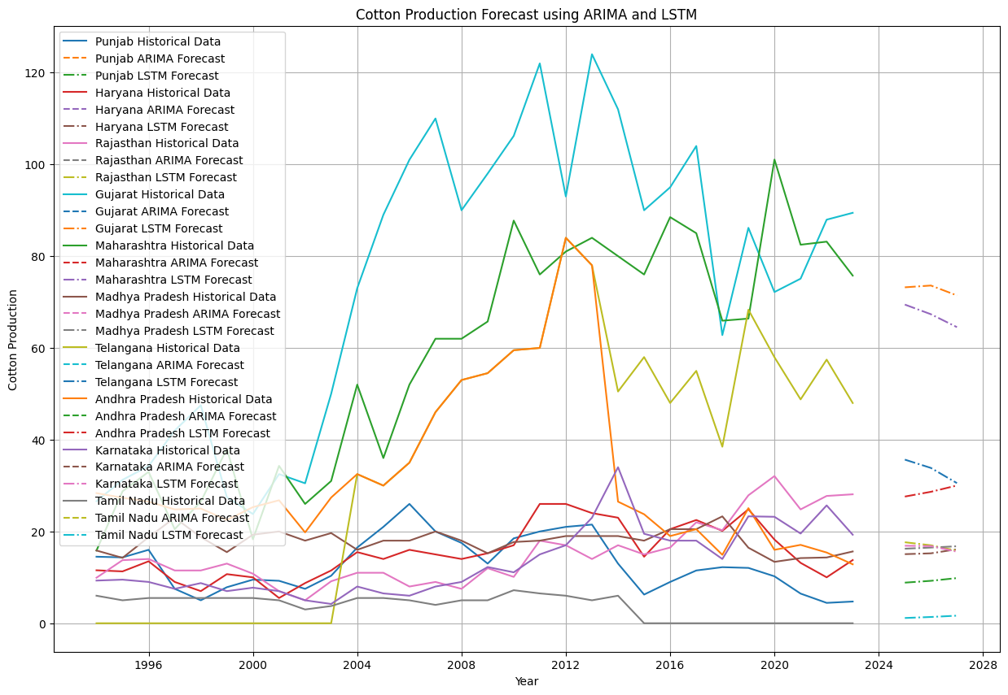

Fig 13. Cotton Production using ARIMA and LSTM

* 1. **PROHPET for state production**

Tab. 7 Prediction for state’s prediction by Prophet (production data is in lakh bales)

|  |  |  |  |
| --- | --- | --- | --- |
| States | 2024 | 2025 | 2026 |
| Maharashtra | 120.0980 | 107.3299 | 114.2387 |
| Gujarat | 97.8906 | 107.6172 | 107.5415 |
| Telangana | 89.6821 | 82.6479 | 87.9895 |
| Rajasthan | 28.5973 | 27.2884 | 28.5852 |
| Karnataka | 22.2469 | 23.8493 | 24.2385 |
| Haryana | 26.6084 | 23.7498 | 25.1422 |
| Andhra Pradesh | 38.5901 | 32.6313 | 34.0839 |
| Madhya Pradesh | 17.0179 | 16.6463 | 16.6031 |
| Punjab | 13.9214 | 12.1765 | 12.5662 |
| Tamil Nadu | -0.0081 | -0.3330 | -0.3160 |

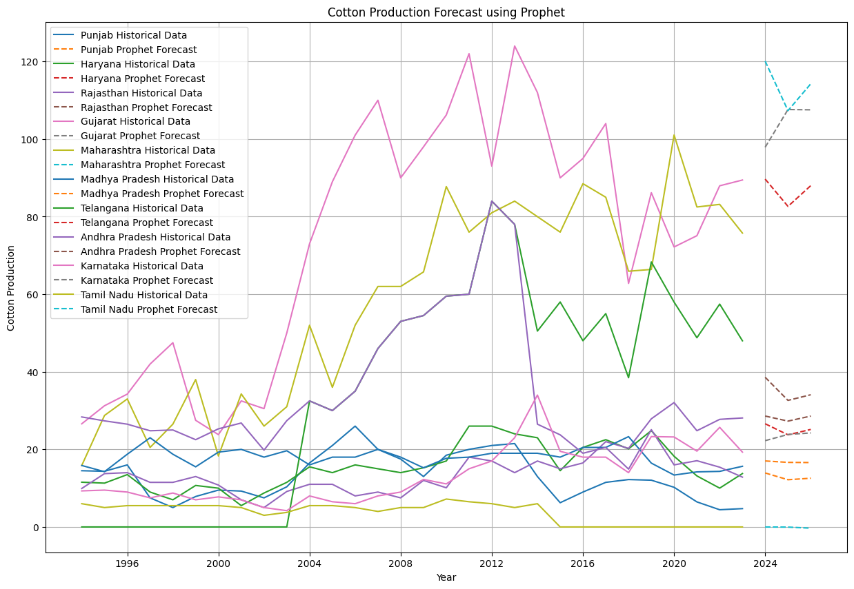

Fig 14. Cotton production forecast using Prophet

* 1. **XGBoost model**

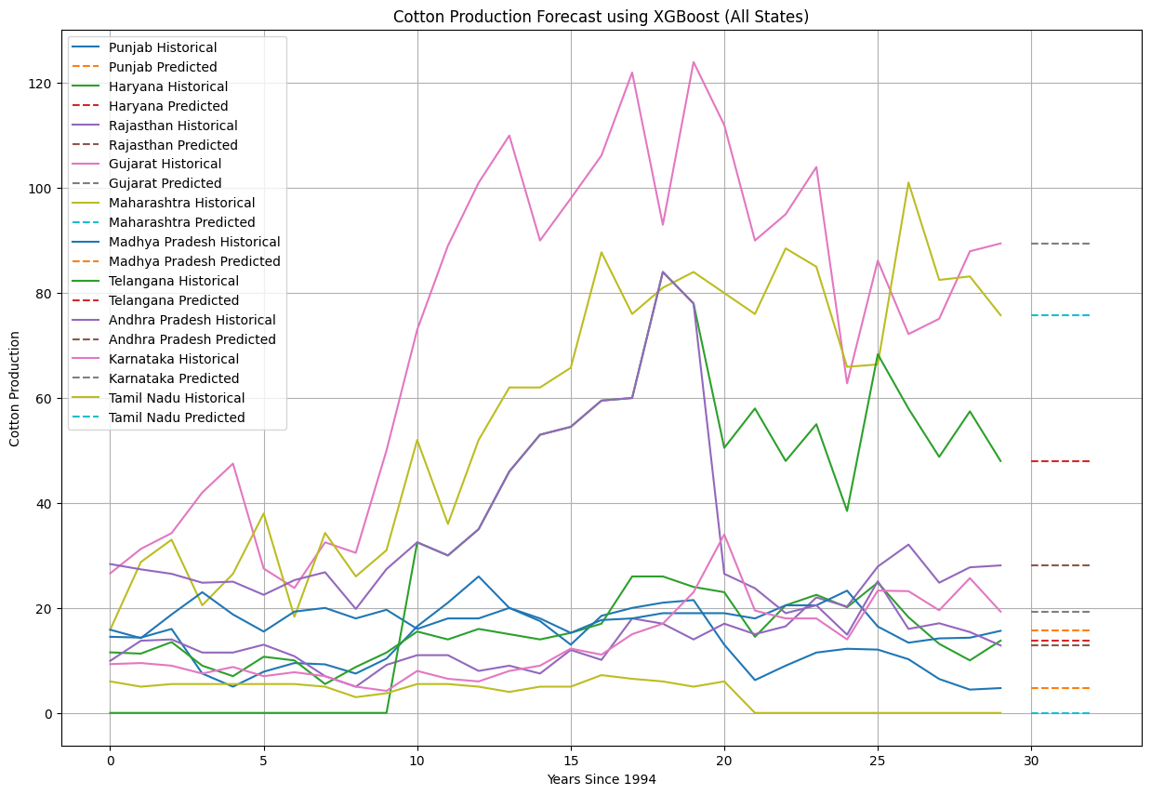

Fig 15 Cotton production using XGBoost

|  |  |  |  |
| --- | --- | --- | --- |
| States | 2024 | 2025 | 2026 |
| Maharashtra | 75.7606 | 75.7606 | 75.7606 |
| Gujarat | 89.4390 | 89.4390 | 89.4390 |
| Telangana | 47.991 | 47.991 | 47.991 |
| Rajasthan | 28.0992 | 28.0992 | 28.0992 |
| Karnataka | 19.2903 | 19.2903 | 19.2903 |
| Haryana | 13.7695 | 13.7695 | 13.7695 |
| Andhra Pradesh | 12.8511 | 12.8511 | 12.8511 |
| Madhya Pradesh | 19.2903 | 19.2903 | 19.2903 |
| Punjab | 4.7294 | 4.7294 | 4.7294 |
| Tamil Nadu | 0.0001 | 0.0001 | 0.0001 |

Tab-8 Prediction value using XGBoost (production data is in lakh bales)

* 1. **Exponential Smoothing model**

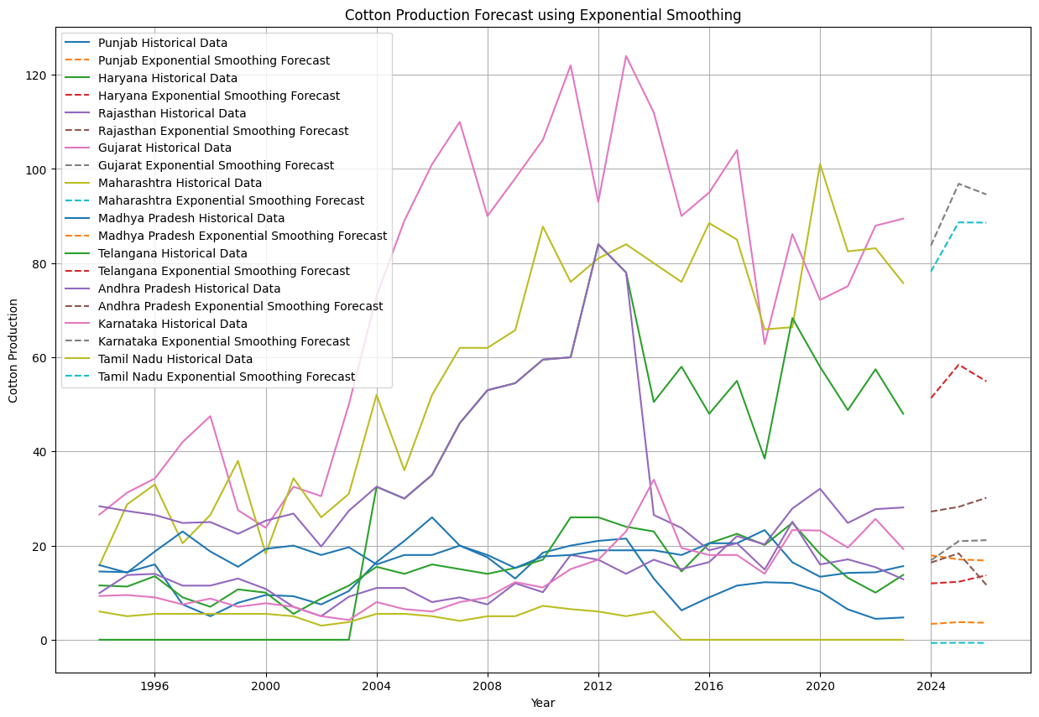

Fig 16 Cotton production using Exponential Smoothing

|  |  |  |  |
| --- | --- | --- | --- |
| States | 2024 | 2025 | 2026 |
| Maharashtra | 78.1995 | 88.6535 | 88.5995 |
| Gujarat | 83.7278 | 96.8572 | 94.5863 |
| Telangana | 51.3196 | 58.42258 | 54.8903 |
| Rajasthan | 27.2250 | 28.2280 | 30.1480 |
| Karnataka | 16.8750 | 20.9354 | 21.1573 |
| Haryana | 11.9641 | 12.3211 | 13.7011 |
| Andhra Pradesh | 16.3948 | 18.3490 | 11.6492 |
| Madhya Pradesh | 17.9155 | 17.0605 | 16.8385 |
| Punjab | 3.36332 | 3.7453 | 3.6163 |
| Tamil Nadu | -0.6836 | -0.6386 | -0.6587 |

Tab 9 Forecasted value using Exponential Smoothing (production data is in lakh bales)

* 1. **Ensemble modelling**

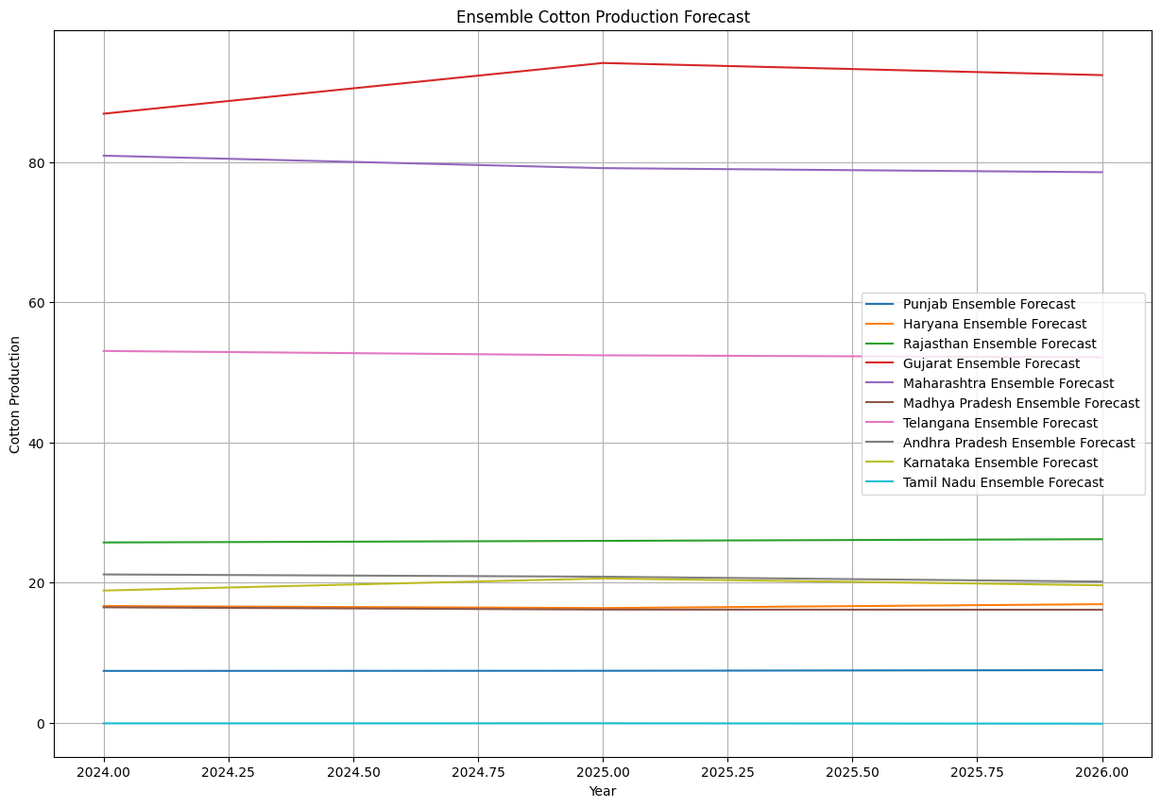

Fig 17 Graphical representation of Ensemble method

|  |  |  |  |
| --- | --- | --- | --- |
| States | 2024 | 2025 | 2026 |
| Maharashtra | 86.9756 | 85.4207 | 84.9592 |
| Gujarat | 87.1055 | 94.3673 | 92.6984 |
| Telangana | 57.6364 | 57.5441 | 57.4956 |
| Rajasthan | 24.6319 | 24.9304 | 25.2776 |
| Karnataka | 19.4260 | 21.1874 | 20.1554 |
| Haryana | 16.0421 | 15.7192 | 16.1953 |
| Andhra Pradesh | 21.0120 | 20.63244 | 19.8754 |
| Madhya Pradesh | 16.4477 | 16.1021 | 16.0605 |
| Punjab | 7.6202 | 7.6732 | 7.8184 |
| Tamil Nadu | 0.0174 | 0.0482 | 0.0189 |

Tab 10. Predicted values of Ensemble methods (production data is in lakh bales)

**5.7 ARIMA for India’s export**

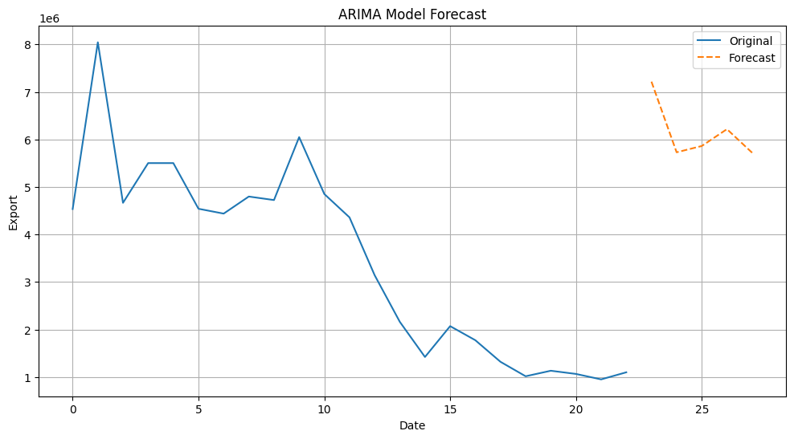Fig 18. ARIMA model forecast

The initial spike around the 2nd time period followed by a series of fluctuations indicates some volatility in the export data.

**Forecast**

The forecast shows a rise and then a slight drop, indicating that the model predicts an increase in exports followed by a decrease.

**Model Performance**

The model seems to capture the downward trend in exports up to the 20th time period. However, the forecasted rise may suggest that the model expects a recovery or an upward adjustment.

The sharp changes in the forecast might indicate that the model is sensitive to recent changes in the data, possibly overfitting to recent volatility. (table 11)

Tab. 11 Export of India using ARIMA

|  |  |
| --- | --- |
| Year | Export (lac rupees) |
| 2024 | 5729258.34 |
| 2025 | 5861889.47 |
| 2026 | 6216345.75 |
| 2027 | 5720616.06 |

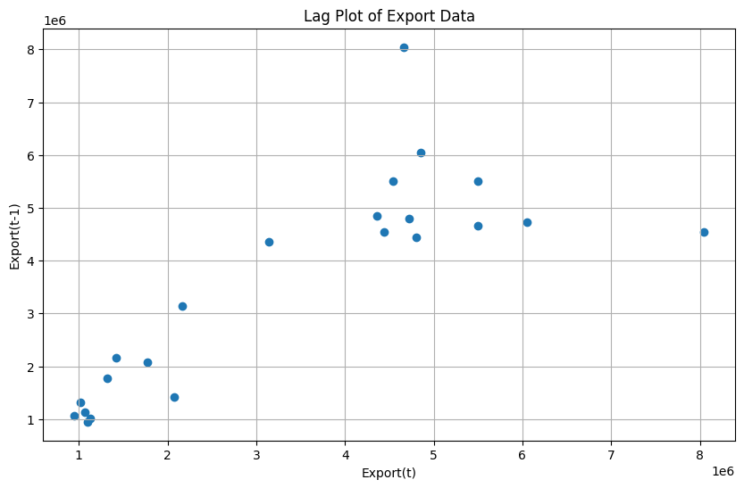

Fig.19 Lag plot for the export

**Pattern identification**

* The lag plot helps identify any autocorrelation in the data. If there is a clear pattern or clustering, it indicates a strong correlation between successive values.
* The points are scattered without forming a clear line or curve, suggesting weak or no autocorrelation in the export data. This could mean that past values are not strong predictors of future values. (fig 19)

**Clusters**

* There are a few clusters around certain export values, such as around 1 million and 5 million. This indicates that these values are more frequently observed in the dataset.
* The absence of a strong linear pattern suggests that the ARIMA model might need more sophisticated differencing or a higher order to capture any underlying patterns.
  1. **LSTM model India’s prediction of export**

Tab. 12 India’s export by LSTM

|  |  |
| --- | --- |
| YEAR | EXPORT (lac rupees) |
| 2024 | 1424300.9 |
| 2025 | 1613717.2 |
| 2026 | 1957660.8 |
| 2027 | 2517095.8 |

* 1. **Prophet model for India’s prediction of export**

Tab. 13 India’s export by Prophet

|  |  |
| --- | --- |
| YEAR | EXPORT (lac rupees) |
| 2024 | 6973922.45 |
| 2025 | 7222031.54 |
| 2026 | 7447965.34 |
| 2027 | 7651832.12 |

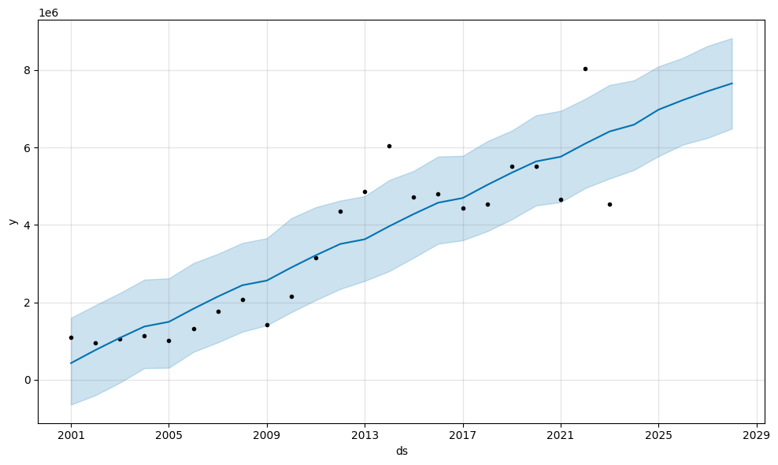

Fig. 20 Prophet model’s prediction

**Actual Data (Black Dots):**

* These points represent the actual historical export data over time.
* The data points show variability and an overall increasing trend.

**Forecast (Blue Line):**

* The blue line represents the forecasted values by the Prophet model.
* The line shows a generally increasing trend, which aligns with the overall trend observed in the historical data. (fig 20)

**Confidence Intervals (Shaded Area):**

* The shaded area around the blue line represents the uncertainty in the forecast, typically the 95% confidence interval.
* The wider the shaded area, the higher the uncertainty in the forecast at that particular point in time.

**Trend Analysis:**

* The forecasted trend shows a steady increase in exports over time. This suggests that the Prophet model has identified an underlying positive trend in the historical data.
* The actual data points (black dots) generally follow this increasing trend, though there is some variability.

**Model Performance:**

* The model appears to fit the historical data well, with the blue line capturing the overall upward trend and many of the data points lying close to the forecast line.
* Some data points fall outside the confidence interval, indicating periods of higher volatility or potential outliers in the historical data.

**Uncertainty and Confidence Intervals:**

* The confidence intervals widen as the forecast extends further into the future, reflecting increasing uncertainty in the predictions. This is typical in time series forecasting.
* The model suggests that while exports are expected to increase, there is significant variability, especially in the later years.

**Long-term Forecast:**

* The model forecasts an increasing trend up to 2029, suggesting that exports are expected to grow.(fig 20)
* The confidence intervals indicate that while the central forecast is positive, there is a range of possible outcomes, highlighting the uncertainty in long-term predictions.
  1. **Ensemble method for prediction of India’s export**

All the methods are combined to calculate the prediction for cotton export.

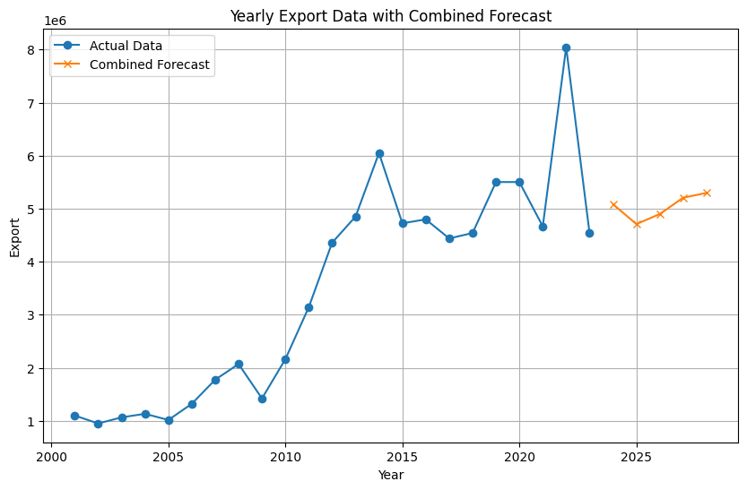

Fig. 21 Yearly export data with combined forecast

Overall, the graph suggests that the India’s' exports have been growing and are expected to continue to grow in the future. However, it is important to note that the forecast is uncertain and could be affected by a number of factors, such as changes in the global economy or trade policies. (fig 21)

* 1. **ARIMA model for top 10 countries export**

Fig. 22 ARIMA model for top 10 countries export

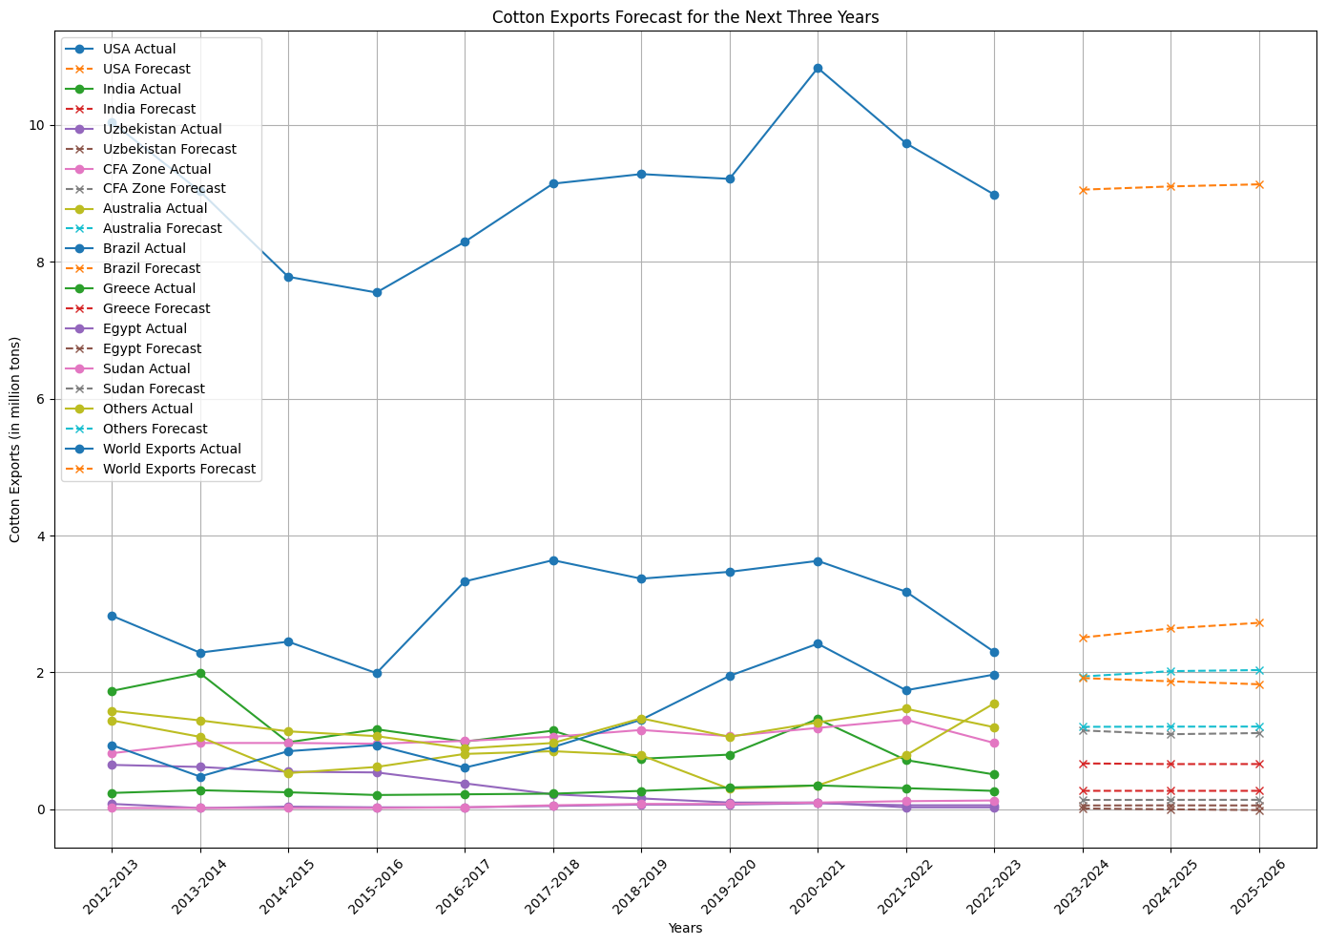

Tab. 14 Top 10 countries export prediction by ARIMA (lac rupees)

|  |  |  |  |
| --- | --- | --- | --- |
| COUNTRIES | 2023-2024 | 2024-2025 | 2025-2026 |
| USA | 2.511094 | 2.642984 | 2.725388 |
| India | 0.671560 | 0.661827 | 0.662414 |
| Uzbekistan | 0.14075 | 0.000854 | -0.010122 |
| CFA Zone | 1.153148 | 1.098322 | 1.114734 |
| Australia | 1.941263 | 2.019390 | 2.034990 |
| Brazil | 1.918044 | 1.870781 | 1.827788 |
| Greece | 0.271149 | 0.271008 | 0.271025 |
| Egypt | 0.057145 | 0.058979 | 0.057801 |
| Sudan | 0.137821 | 0.139377 | 0.139687 |
| Others | 1.205921 | 1.208581 | 1.209776 |

* USA and Australia Lead Growth:

The USA's cotton exports are projected to steadily rise from 2.511 million tons in 2023-2024 to 2.725 million tons in 2025-2026. (table 14)

Australia's exports are also expected to increase from 1.941 million tons to 2.035 million tons over the same period.(table 14)

* Stability and Minor Fluctuations:

India’s exports remain relatively stable around 0.662 million tons each year.

Minor fluctuations are observed in regions like CFA Zone, Greece, Egypt, and Sudan, with slight increases or stable exports. (table 14)

* Overall Global Increase:

World cotton exports are predicted to grow steadily from 9.053 million tons in 2023-2024 to 9.130 million tons by 2025-2026, reflecting a general upward trend in global export volumes. (table 14)

**5.11 Exponential Smoothening for top 10 countries export**

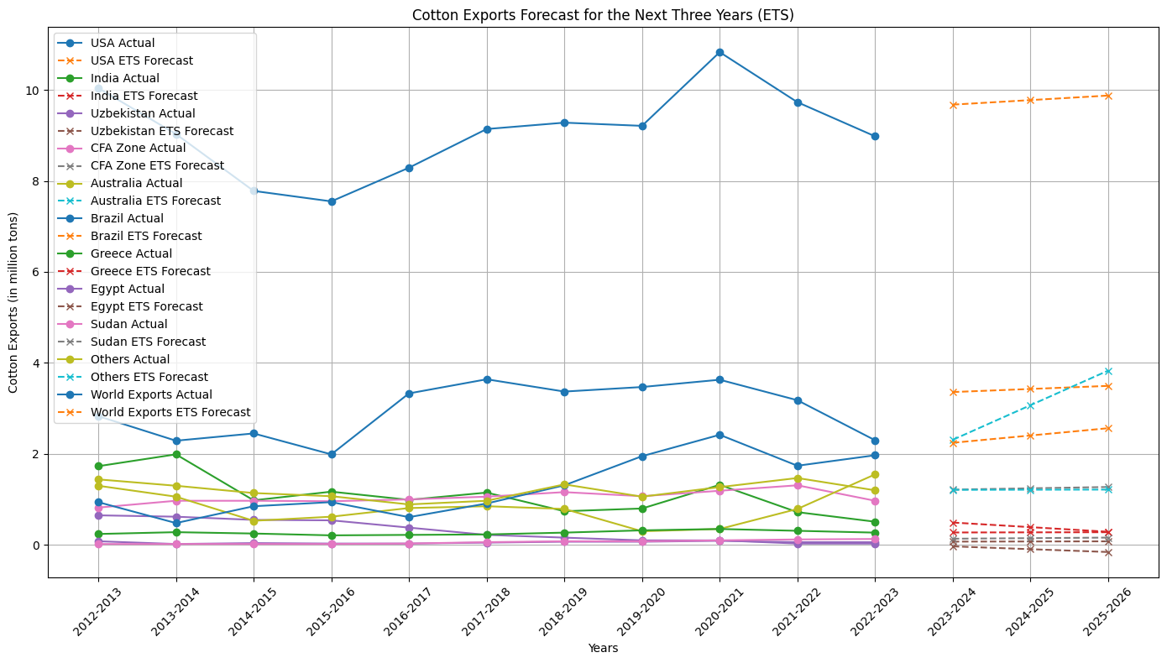

Fig. 23 Cotton exports forecast for the next three years (ETS)

Tab. 15 Prediction by Exponential Smoothening for top 10 countries (lac rupees)

|  |  |  |  |
| --- | --- | --- | --- |
| Countries | 2023-2024 | 2024-2025 | 2025-26 |
| USA | 3.359430 | 3.427191 | 3.494953 |
| India | 0.491591 | 0.390205 | 0.288818 |
| Uzbekistan | -0.032034 | -0.09406 | -0.15610 |
| CFA Zone | 1.215390 | 1.244019 | 1.272647 |
| Australia | 2.31 | 3.07 | 3.83 |
| Brazil | 2.44425 | 2.404576 | 2.564726 |
| Greece | 0.272999 | 0.275998 | 0.278998 |
| Egypt | 0.072379 | 0.075344 | 0.078308 |
| Sudan | 0.136015 | 0.148282 | 0.160749 |
| Others | 1.210365 | 1.213002 | 1.215638 |

* Significant Growth in Key Exporters:

The USA is expected to see a steady increase in cotton exports, rising from 3.359 million tons in 2023-2024 to 3.495 million tons by 2025-2026. (tab 15)

Australia shows a notable increase from 2.31 million tons to 3.83 million tons over the same period.

Brazil's exports are also predicted to grow, from 2.244 million tons to 2.565 million tons.

* Overall Increase in Global Exports:

World cotton exports are projected to increase from 9.676 million tons in 2023-2024 to 9.875 million tons by 2025-2026. (tab 15)

Most other regions, including CFA Zone, Greece, Egypt, and Sudan, exhibit smaller but consistent growth, contributing to the overall rise in global cotton exports. India's exports are expected to decline, while Uzbekistan shows negative growth.

* 1. **Prophet model**

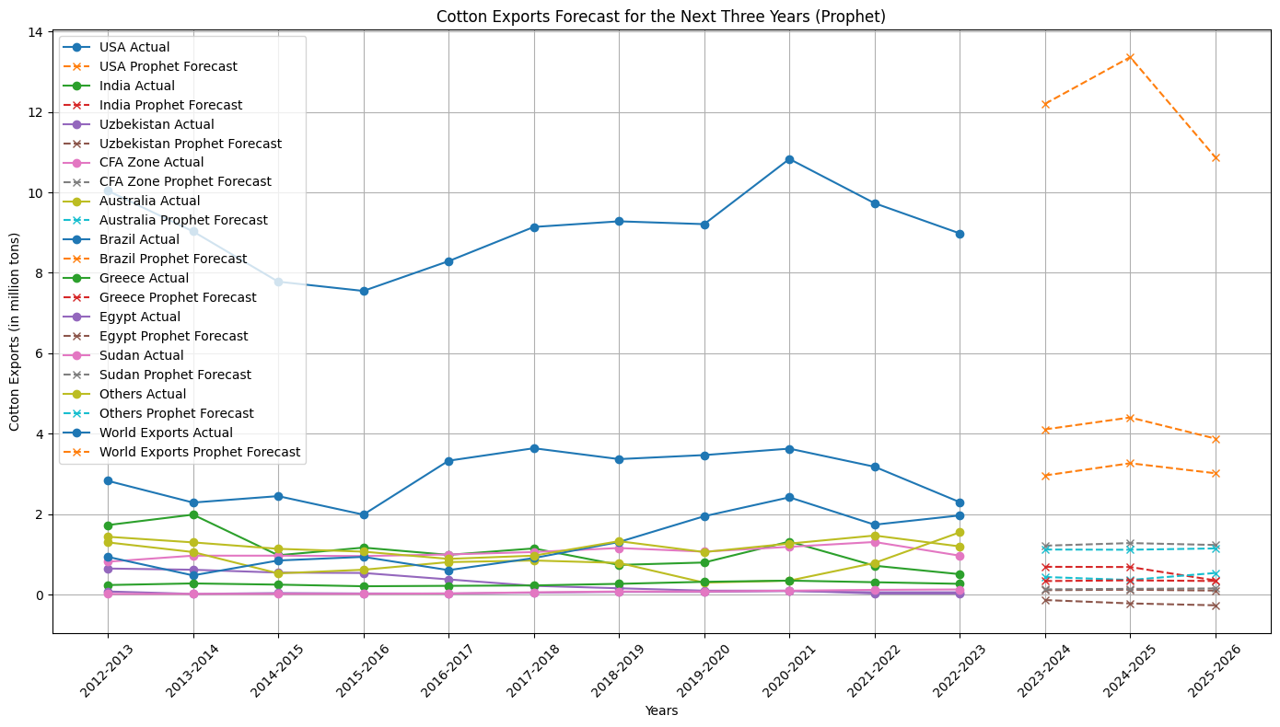

Fig. 24 Cotton Exports Forecast for the Next three years(Prophet)

Tab. 16 Prediction by Prophet model for top 10 countries (lac rupees)

|  |  |  |  |
| --- | --- | --- | --- |
| Countries | 2023-2024 | 2024-2025 | 2025-2026 |
| USA | 4.108467 | 4.404350 | 3.880188 |
| India | 0.692936 | 0.687650 | 0.355291 |
| Uzbekistan | -0.133399 | -0.216584 | -0.263516 |
| CFA Zone | 1.218169 | 1.283091 | 1.235344 |
| Australia | 0.439613 | 0.365853 | 0.539996 |
| Brazil | 2.963870 | 3.267079 | 3.018005 |
| Greece | 0.339034 | 0.356112 | 0.340162 |
| Egypt | 0.112072 | 0.123801 | 0.102470 |
| Sudan | 0.131851 | 0.145681 | 0.155593 |
| Others | 1.122492 | 1.117374 | 1.149796 |

1. **Model Evaluation**

In order to ensure the generalizability of the models and prevent overfitting, cross-validation was used to divide the data into training and validation sets. Using grid search or random search approaches, hyperparameter tuning was carried out to optimize model parameters, improving accuracy and performance.

1. **Prediction**

For the next three years, projections were made on the percentage increase in cotton production in each state. A reliable forecast was created by combining forecasts from the ARIMA, Prophet, and LSTM models using ensemble methods. By utilizing the advantages of each model, this strategy produced forecasts that were more trustworthy and accurate.

The above observation can be concluded that Arima model is best fitted in comparison to remaining two models.

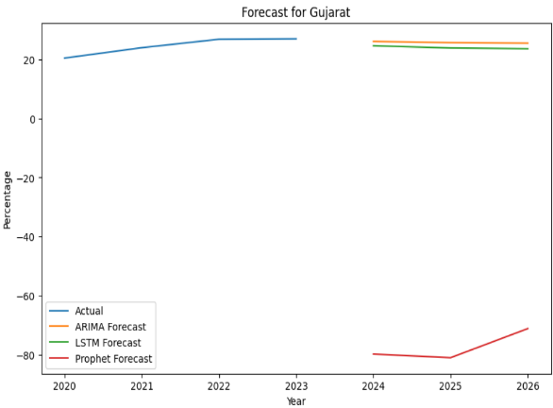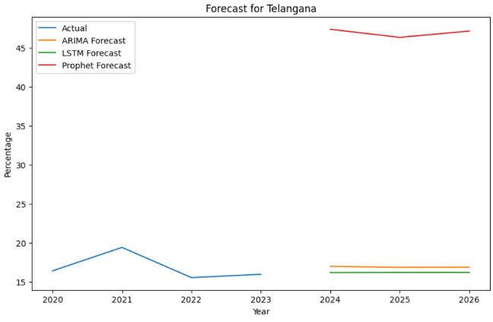

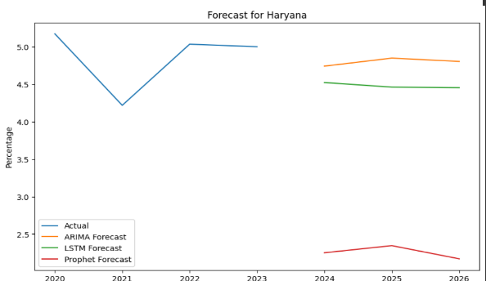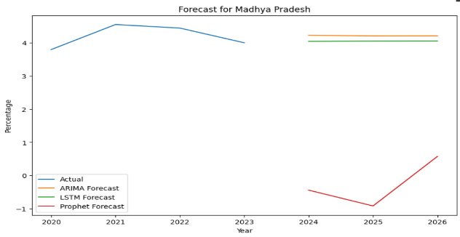

Fig. 25 Forecasting graph for state’s production

1. **Error Calculation:**

Error measures such Mean Absolute Error (MAE), Mean Squared Error (MSE), and Root Mean Squared Error (RMSE) were used to assess the performance of the model. The accuracy and dependability of the models were revealed by these indicators. The model with the best performance was chosen for the final forecasts after comparison of its outputs. The three models' errors are compared using the MAE, MSE, and RMSE calculations. Because of its large inaccuracy, the prophet model is not particularly helpful in making such predictions.

$$MAE=\frac{1}{n}\sum_{i=1}^{n}{|y_{i}-{\hat{y}}_{i}|}$$

$$MSE=\frac{1}{n}\sum_{i=1}^{n}{\left(y_{i}-{\hat{y}}_{i}\right)\left(y_{i}-{\hat{y}}_{i}\right)}$$

$$RMSE=\sqrt{\frac{1}{n}}\sum_{i=1}^{n}{{{(y}_{i}-{\hat{y}}_{i})}^{2}}$$

**8.1 ERROR IN STATE PRODUCTION**

Tab. 17 Error calculation for state production

|  |  |  |  |  |  |  |  |  |  |  |
| --- | --- | --- | --- | --- | --- | --- | --- | --- | --- | --- |
| States | ARIMA | | LSTM | | Exponential Smoothing | | XGBoost | | Ensemble methods | |
|  | RMSE | MAE | RMSE | MAE | RMSE | MAE | RMSE | MAE | RMSE | MAE |
| Maharashtra | 2.98 | 2.32 | 9.34 | 9.14 | 8.43 | 7.54 | 5.77 | 4.71 | 6.05 | 5.32 |
| Gujarat | 5.57 | 4.74 | 5.93 | 5.81 | 7.76 | 7.56 | 8.33 | 5.28 | 8.09 | 7.23 |
| Telangana | 5.17 | 3.27 | 4.27 | 2.90 | 4.28 | 3.47 | 5.48 | 3.42 | 7.50 | 6.15 |
| Rajasthan | 1.01 | 0.94 | 14.45 | 14.34 | 1.85 | 1.65 | 1.91 | 1.22 | 2.30 | 1.94 |
| Karnataka | 1.29 | 1.02 | 4.53 | 3.62 | 3.32 | 3.10 | 3.69 | 2.22 | 2.64 | 1.83 |
| Haryana | 6.32 | 6.00 | 2.81 | 2.30 | 1.50 | 1.19 | 2.20 | 1.46 | 3.95 | 3.67 |
| Andhra Pradesh | 3.18 | 2.55 | 11.52 | 11.19 | 1.88 | 1.61 | 2.85 | 2.26 | 5.54 | 5.39 |
| Madhya Pradesh | 0.99 | 0.92 | 1.77 | 1.70 | 2.75 | 2.55 | 1.12 | 0.92 | 1.67 | 1.48 |
| Punjab | 2.52 | 2.06 | 5.01 | 4.87 | 1.94 | 1.64 | 1.01 | 0.67 | 2.67 | 2.49 |
| Tamil Nadu | 0.00 | 0.00 | 0.93 | 0.92 | 0.66 | 0.66 | 0.00 | 0.00 | 0.03 | 0.03 |

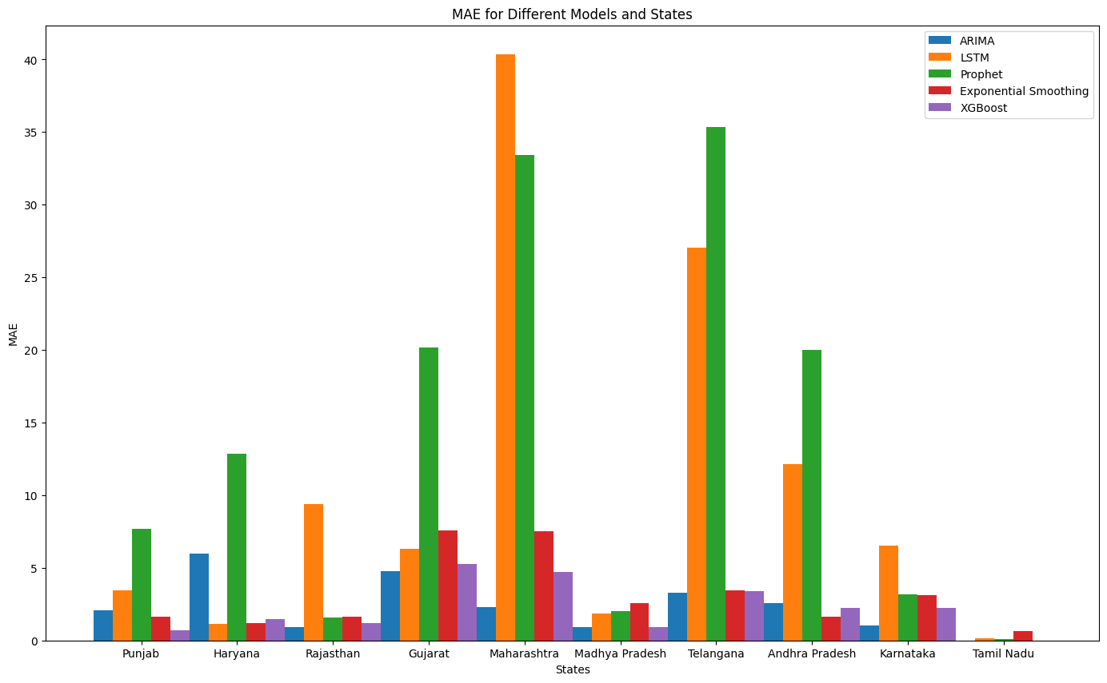

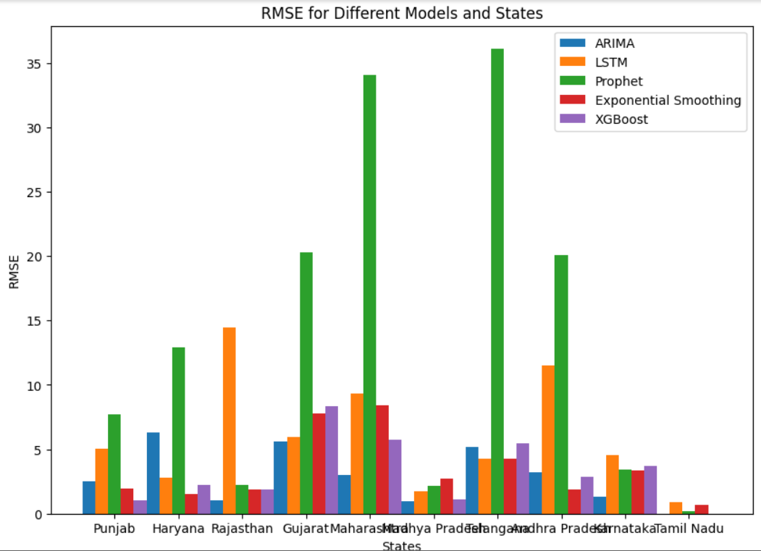

Fig.26 Error comparison of ARIMA, LSTM, Prophet, XGBoost, Exponential Smoothing models

**8.2 ERROR IN TOP 10 COUNTRIES EXPORT MODEL**

Tab. 18 Error calculation for top 10 countries

|  |  |  |  |  |
| --- | --- | --- | --- | --- |
| **Country** | **Model** | **MAE** | **MSE** | **RMSE** |
| USA | Arima | 0.394783 | 0.268287 | 0.517965 |
| ETS | 0.852981 | 1.209452 | 1.099751 |
| Prophet | 1.318946 | 2.092937 | 1.446699 |
| India | Arima | 0.296660 | 0.206653 | 0.454591 |
| ETS | 0.470147 | 0.273527 | 0.522999 |
| Prophet | 0.691557 | 0.543043 | 0.736914 |
| Uzbekistan | Arima | 0.052838 | 0.003061 | 0.055324 |
| ETS | 0.110415 | 0.013728 | 0.117165 |
| Prophet | 0.153695 | 0.025318 | 0.159117 |
| CFA Zone | Arima | 0.157555 | 0.029553 | 0.171909 |
| ETS | 0.134444 | 0.027670 | 0.166343 |
| Prophet | 0.201662 | 0.044905 | 0.211908 |
| Australia | Arima | 0.784505 | 0.847234 | 0.920453 |
| ETS | 0.882382 | 1.152179 | 1.073396 |
| Prophet | 0.631269 | 0.650946 | 0.806812 |
| Brazil | Arima | 0.238291 | 0.062373 | 0.249746 |
| ETS | 0.777012 | 0.779737 | 0.883027 |
| Prophet | 0.275131 | 0.094861 | 0.307995 |
| Greece | Arima | 0.033386 | 0.001497 | 0.038689 |
| ETS | 0.110000 | 0.017500 | 0.132288 |
| Prophet | 0.058004 | 0.005461 | 0.073897 |
| Egypt | Arima | 0.013394 | 0.000194 | 0.013932 |
| ETS | 0.032440 | 0.001508 | 0.038827 |
| Prophet | 0.016561 | 0.000374 | 0.019343 |
| Sudan | Arima | 0.039178 | 0.001700 | 0.041229 |
| ETS | 0.036667 | 0.001500 | 0.038730 |
| Prophet | 0.029182 | 0.000858 | 0.029287 |
| Others | Arima | 0.196184 | 0.052060 | 0.228167 |
| ETS | 0.372842 | 0.151290 | 0.388960 |
| Prophet | 0.483119 | 0.240065 | 0.489964 |

Tab. 19 Average model comparison for top 10 countries export

|  |  |  |  |
| --- | --- | --- | --- |
| MODEL | MAE | MSE | RMSE |
| Arima | 0.268675 | 0.209208 | 0.327484 |
| ETS | 0.407819 | 0.377205 | 0.450283 |
| Prophet | 0.415394 | 0.42587 | 0.500822 |

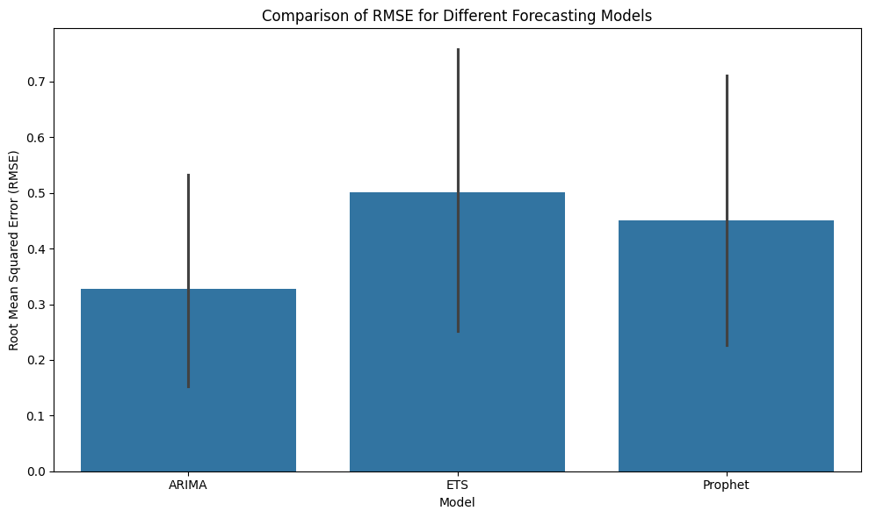

Fig. 27 Comparison of RMSE for different Forecasting Models

Based on RMSE:

* ARIMA has the lowest RMSE (0.327), indicating it performs best in terms of overall predictive accuracy among the three models.
* Prophet follows with an RMSE of 0.450, which is higher than ARIMA but lower than ETS.

ETS has the highest RMSE of 0.501, suggesting it has the least accurate predictions among the models tested.

The study conducted a comprehensive analysis of predicting cotton production and export dynamics using ARIMA, LSTM, Exponential Smoothing, XGBosst and Prophet models. The ARIMA model demonstrated superior performance in forecasting state-wise cotton production, with consistently lower error rates across various states. For example, states like Rajasthan, Gujarat, Maharashtra, Madhya Pradesh, Karnataka and Tamil Nadu exhibited significantly accurate predictions when using the ARIMA model, highlighting its efficacy in handling time series forecasting for this specific application. Haryana and Andhra Pradesh were forecasted with minimum error by Exponential Smoothing. Punjab by XGBoost and Telangana by LSTM. In contrast, the LSTM and Prophet models showed higher variability in their predictions, indicating that ARIMA's statistical approach might be better suited for the relatively stable trends observed in cotton production data.

When analysing India's export predictions, the ARIMA model again outperformed the LSTM and Prophet models, predicting an increase in cotton exports for the years 2024 to 2027. The ARIMA model's lower Mean Absolute Error (MAE), Mean Squared Error (MSE), and Root Mean Squared Error (RMSE) metrics compared to the other models underscore its accuracy and reliability. This consistent performance suggests that ARIMA's time series methodology is particularly effective for predicting export dynamics, which can exhibit both seasonal patterns and long-term trends. Despite the Prophet model's ability to capture broader trends, its higher error rates imply that it might not be as effective in contexts with high volatility, such as cotton exports.

The top 10 cotton-exporting countries' analysis further reinforced the ARIMA model's robustness. It consistently showed the lowest error metrics, making it the most reliable model among the three tested. The LSTM model, while having some successes in certain state-wise predictions, exhibited higher error rates overall, suggesting that neural network-based models may require more fine-tuning and larger datasets to achieve optimal performance. Ensemble methods, which combined forecasts from all three models, provided a holistic view but still highlighted ARIMA's dominance in predictive accuracy. This study's findings indicate that traditional statistical models like ARIMA can offer significant advantages in specific forecasting scenarios, especially where historical data patterns are relatively stable and well-defined. USA is the country which would be exporting highest as per the prediction.

**Conclusion and Discussion**

The ARIMA model turns out to be the most powerful tool in predicting the dynamics of cotton production and export. It is better than the LSTM and Prophet models on accuracy and reliability. Its strong performance on different states and in the forecasting of the export trend of India makes it appropriate for time series forecasting within the agricultural sector. In the case of states like Maharashtra, Gujarat, and Telangana, the ARIMA model gives lower error rates in the predictions for cotton production, underlining its handling capacity of finesse involved with agriculture data and, therefore, making it a very useful tool for policymakers and other stakeholders in the cotton industry.

It’s very good results, pegged for consistency when applied to forecasting cotton exports from India, further underline its reliability. The prediction of an increase in exports between 2024 and 2027 has very valuable insights for strategic planning and positioning in the market. This model is more reliable on MAE, MSE, and RMSE metrics, hence it is very capable of predicting export dynamics with a very high degree of accuracy, thus able to retain competitive edge across the global cotton market. Although it captured long-term trends, the Prophet model came short because of a higher error rate. Variability in the performance of the LSTM model suggests that traditional time series approaches, like ARIMA, are more suitable for this particular application.

The results also underline the power of ensemble methods in offering full forecasts, considering the strong points of different models. In this research, however, ARIMA was beyond doubt dominant at the frontiers of predictive accuracy, thus further confirming its status as the best fit for this particular forecasting task. The results suggest that there is no need to look beyond traditional statistical models in an attempt to use newer machine learning approaches, especially in contexts where patterns in historical data are relatively stable. Thus, the success of the ARIMA model in this study proves it to be a formidable tool in helping with better decision-making processes and strategic planning in regard to the cotton industry.

**Future Scope**

This study presents a number of directions for additional studies. First off, adding external factors to the forecasting models—like fluctuations in markets, meteorological information, or financial indicators—might increase their robustness and accuracy. We would have a greater understanding of the elements driving productivity in the farming sector if we included external influences.   
Industry stakeholders could also profit from studying how customer demands, legislative changes, and technological improvements affect the manufacturing process. Subsequent investigations could delve into the continual shifts of the food sector and its consequences for patterns of production and prediction precision.

**References**

1. Manickam, Dinesh. (2024). A STUDY ON GROWTH WITH IMPACT OF IMPORTS AND EXPORTS TRADE IN INDIA.

(<https://www.researchgate.net/publication/378482244_A_STUDY_ON_GROWTH_WITH_IMPACT_OF_IMPORTS_AND_EXPORTS_TRADE_IN_INDIA>)

1. Cheng-Hong Yang, Cheng-Feng Lee, Po-Yin Chang, Export- and import-based economic models for predicting global trade using deep learning, Expert Systems with Applications, Volume 218,2023,119590,ISSN 0957-4174, https://doi.org/10.1016/j.eswa.2023.119590.
2. Haoyun Xu, Chukiat  Chaiboonsri and Kanchana  Chokethaworn (2023) Research on Export Prediction Model Based on Machine Learning: Application of China’s Agricultural Products Export , Research on export prediction model based on machine learning: Application of China’s Agricultural Products Export. Available at: https://dl.acm.org/doi/fullHtml/10.1145/3592686.3592733).
3. Tong, Ye. (2023). Literature Review in International Trade Forecasting Based in Machine Learning Method. SHS Web of Conferences. 154. 03025. 10.1051/shsconf/202315403025.
4. ošić, Hrvoje & Žmuk, Berislav. (2022). A Machine Learning Approach to Forecast International Trade: The Case of Croatia. Business Systems Research Journal. 13. 144-160. 10.2478/bsrj-2022-0030.
5. Nirmala, Muthu & M, Vadivel. (2022). A Study on Performance Evaluation of Imports and Exports on Economic Growth in India. The International journal of analytical and experimental modal analysis. 11. 1025-1032.
6. Razia, S.A. and Ramesh  Pranav (2022) *Gale - product login*. Available at: https://galeapps.gale.com/apps/auth?actionCmd=DO_DOWNLOAD_DOCUMENT&callistoContentSet=GALE&da=true&docId=GALE%7CCX3418502164&documentTitle=Contributors&downloadFormat=PDF&inPS=true&origURL=https%3A%2F%2Fgo.gale.com%2Fps%2FdownloadDocument.do%3FtabID%3DT001&prodId=AONE&prodId=AONE&resultClick=true&userGroupName=googlescholar&userGroupName=googlescholar&workId=ges_06_03989-p.pdf%7Cges_06_03996-p.pdf (Accessed: 03 August 2024).
7. Rupali, Amrit Raj and Pathania, G.S. (2021) *An analytical study on Indian Import Export System of India*. Available at: https://ijcrt.org/papers/IJCRT2105171.pdf
8. Alam, Teg. (2019). Forecasting exports and imports through artificial neural network and autoregressive integrated moving average. Decision Science Letters. 8. 249-260. 10.5267/j.dsl.2019.2.001.
9. Jyoti  Kumari (2014) Export, import and economic growth in India: A study. Available at:https://managementdynamics.researchcommons.org/cgi/viewcontent.cgi?article=1106&context=journal.
10. <https://cicr.org.in/resources/resource-datasets>

**Appendix**

State wise product

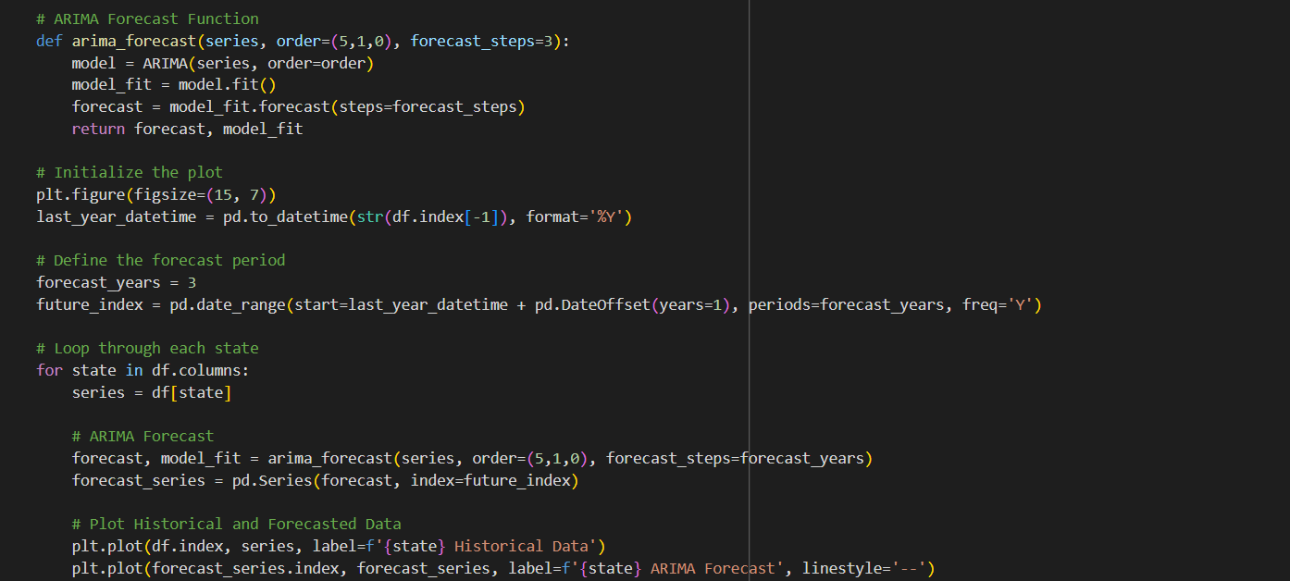

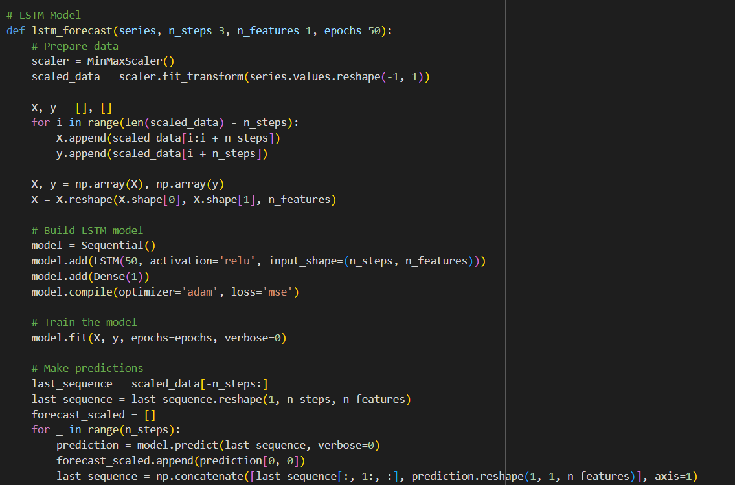

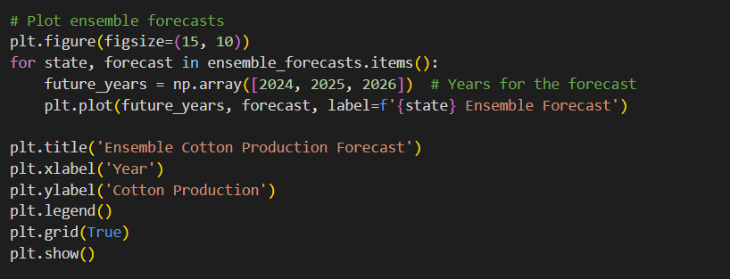

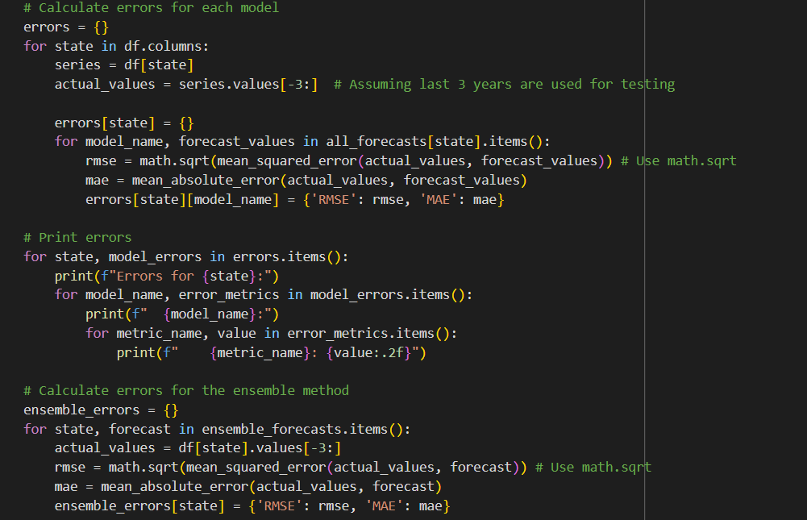

Top 10 countries export

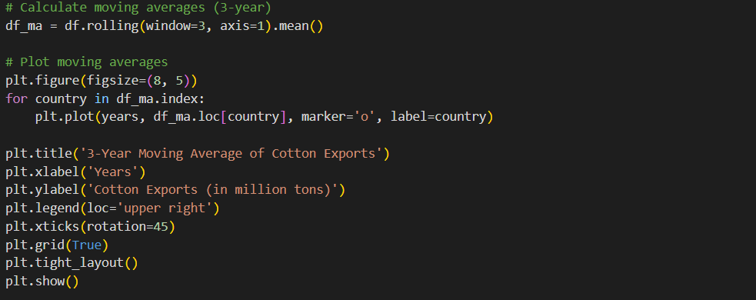

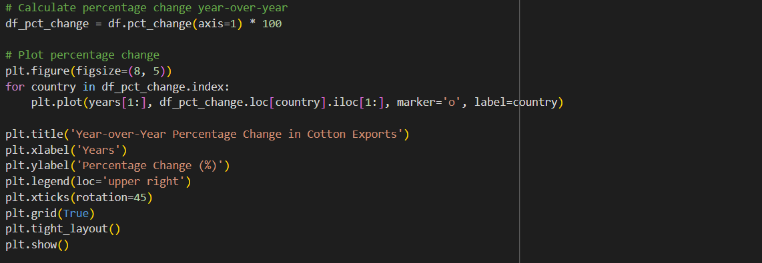

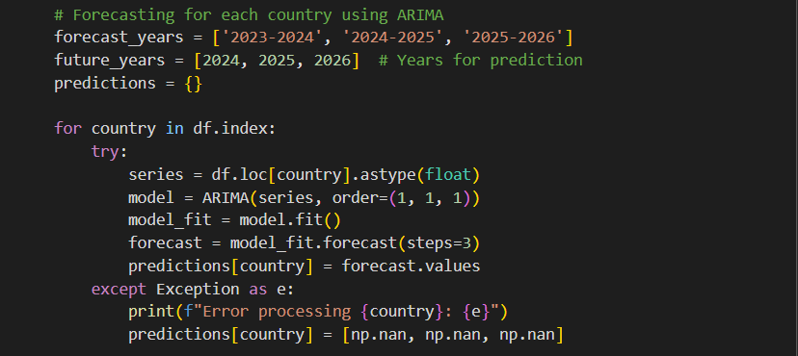

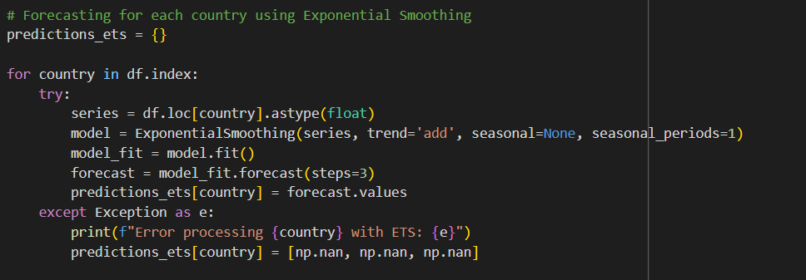

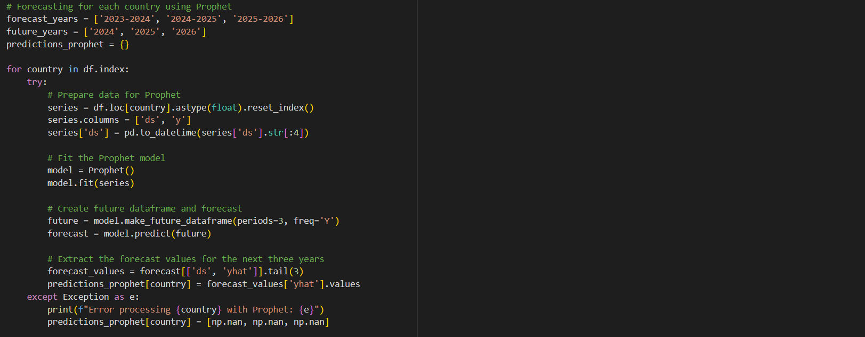

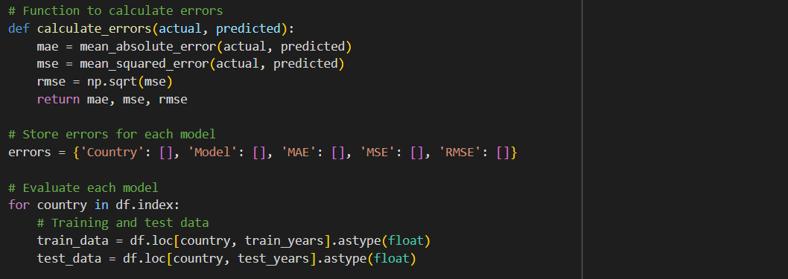

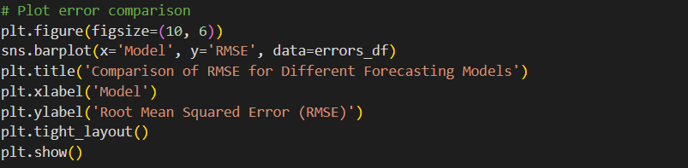

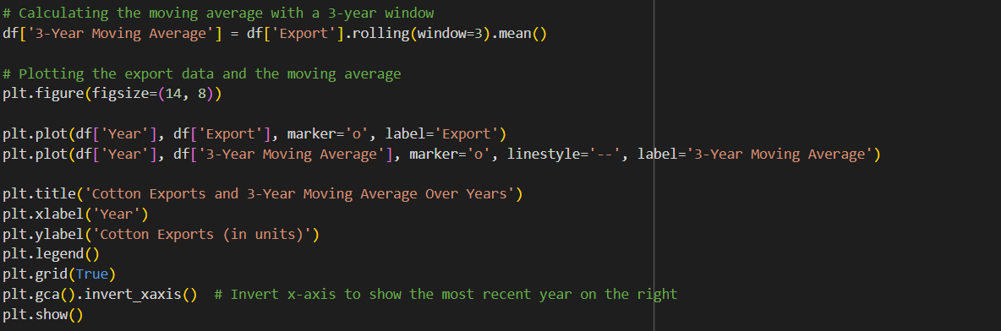



**Proforma 4**

**Undertaking from the PG student while submitting his/her final dissertation to his respective institute**

**Ref. No. _________**

I , the following student

|  |  |  |  |  |
| --- | --- | --- | --- | --- |
| **Sr. No.** | **Sequence of student’s names on a dissertation** | **Students name** | **Name of the Institute & Place** | **Email & Mobile** |
| 1. | First Author | Kriyanshi Ghodasara | SIG | Email: 23070243017@sig.ac.in  Mobile:9624009006 |

**Note:** Put additional rows in case of more number of students

hereby give an undertaking that the dissertation ‘Harvesting Insights: Advanced predictive modelling for cotton Export dynamics’ been checked for its Similarity Index/Plagiarism through Turnitin software tool; and that the document has been prepared by me and it is my original work and free of any plagiarism. It was found that:

|  |  |  |
| --- | --- | --- |
| 1. | The Similarity Index (SI) was:  *(Note: SI range: 0 to 10%; if SI is >10%, then authors cannot communicate ms;* ***attachment of SI report is mandatory****)* | 4% |
| 2. | The ethical clearance for research work conducted obtained from:  *(Note: Name the consent obtaining body; if ‘not applicable’ then write so)* | NA |
| 3. | The source of funding for research was:  *(Note: Name the funding agency; or write ‘self’ if no funding source is involved)* | Self |
| 4. | Conflict of interest:  *(Note: Tick √ whichever is applicable)* | No |
| 5. | The material (adopted text, tables, figures, graphs, etc.) as has been obtained from other sources, has been duly acknowledged in the manuscript:  *(Note: Tick √ whichever is applicable)* | Yes |

In case if any of the above-furnished information is found false at any point in time, then the University authorities can take action as deemed fit against all of us.



|  |  |
| --- | --- |
| Kriyanshi Suresh Ghodasara | Name &  Signature of SIU Guide/Mentor |
| Date: | Endorsement by  Academic Integrity Committee (AIC) |

Place: Pune

**Note:** It is mandatory that the Similarity Index report of plagiarism (only first page) should be appended to the UG/PG dissertation